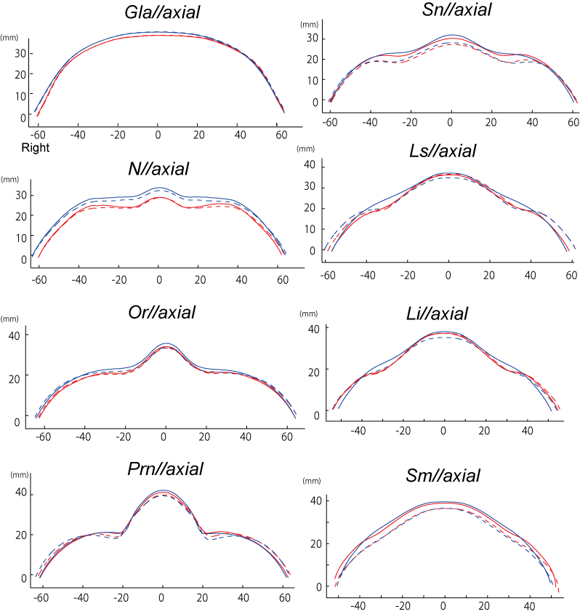
S9 Fig. The mean contours of Gla//axial, N//axial, Or//axial, Prn//axial, Sn//axial, Ls//axial, Li//axial, and Sm//axial in the older group (red lines) and the younger group (blue line). Rest posture was represented as the solid line and the smile posture was represented as the dotted line.

