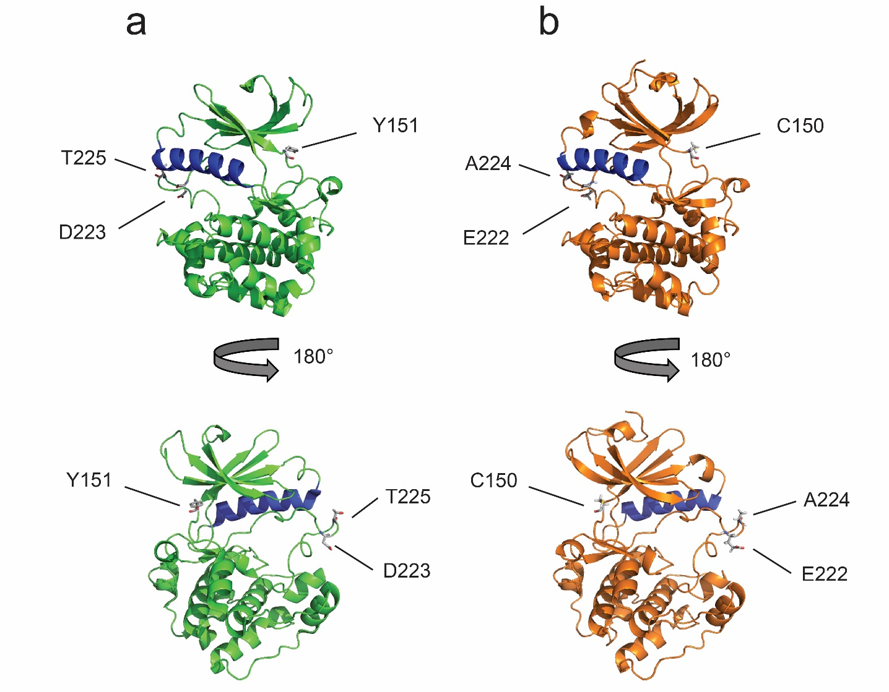

S4 Fig. Structural comparison of crystal structures of S6K1 and homology models of S6K2. The αC helix is shown in blue and the side chains of key residues mentioned in the text are rendered as sticks. (a) Crystal structure of S6K1 (PDB ID: 4L3J). (b) Homology model of S6K2 based on the structure in (a).

