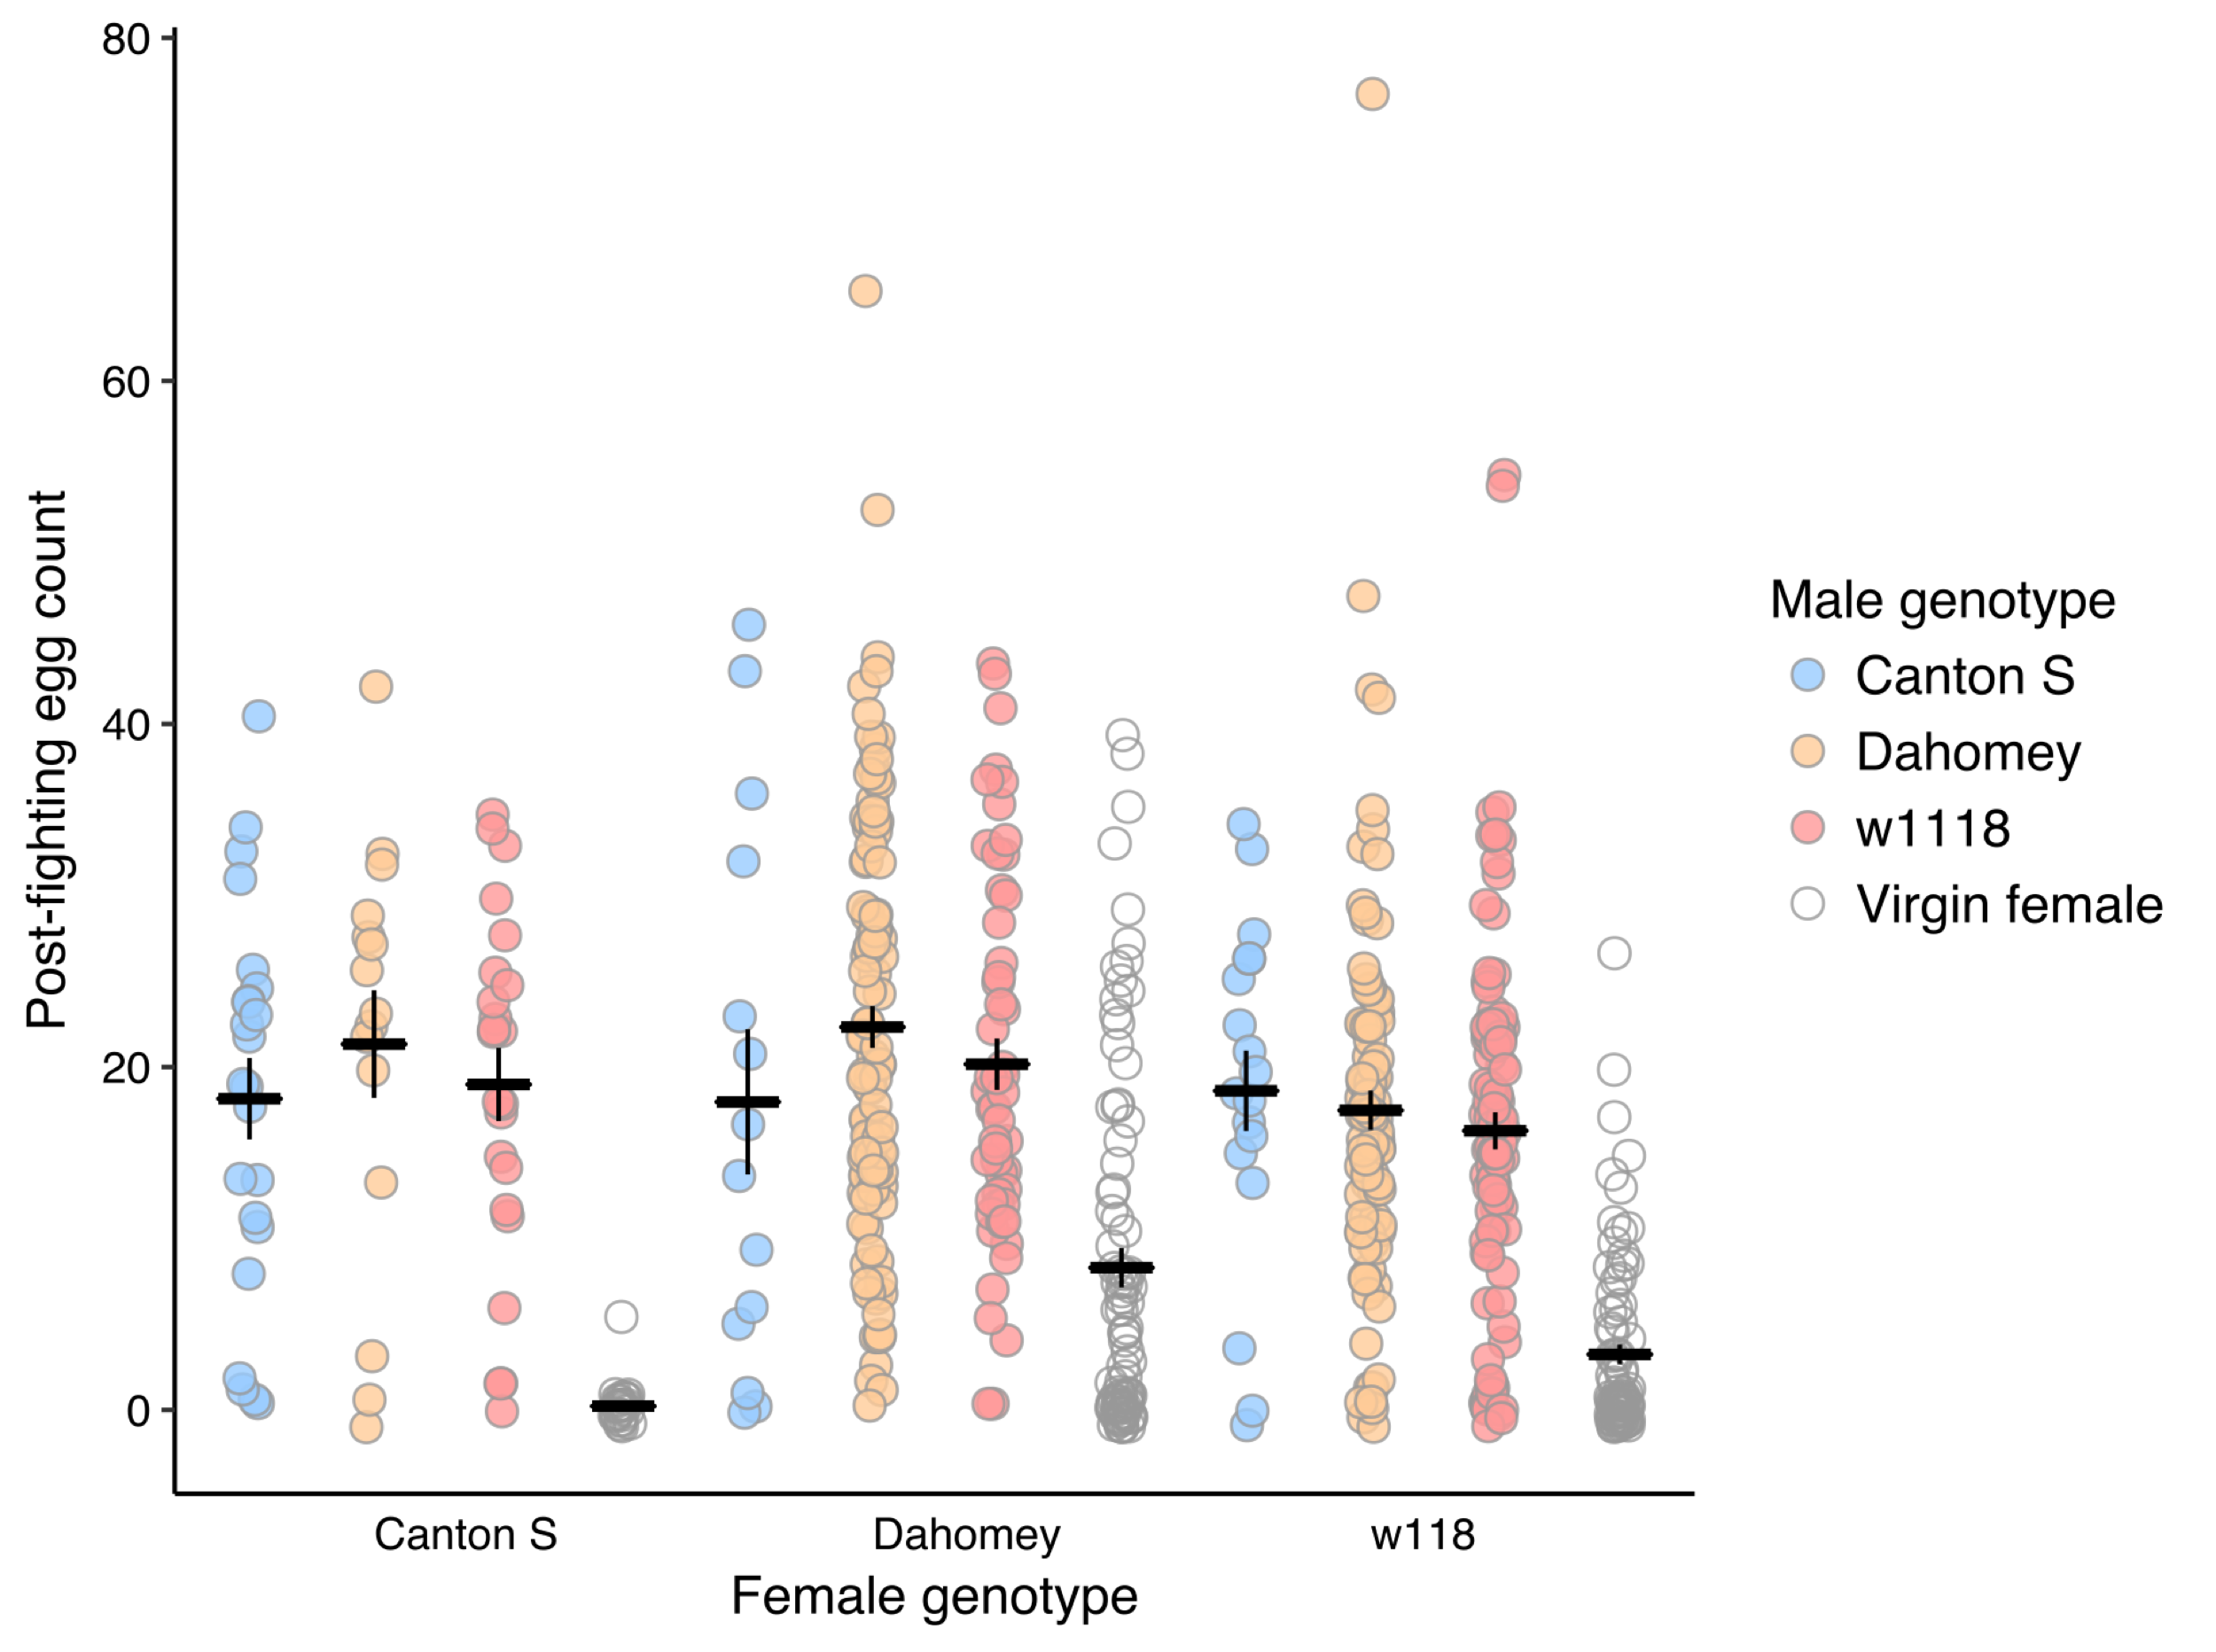
Supplementary Figure 6: Egg counts for 24 hours post-contest (48-72 hours post-mating)
Colours indicate the genotype of the male that a female mated with – blue = Canton-S, yellow = Dahomey, red = w¹¹¹⁸, empty circle = virgin female. Black bars indicate treatment means ± 1 standard error.

