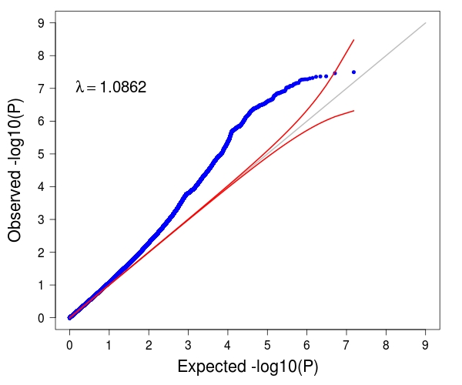
Supplementary Figure 9

Distribution of the observed and expected association P values for the GWAS of allergic disease age-of-onset in the UK Biobank study (n=117,130), after adjusting single-SNP results for the effects of independently associated variants (i.e. with P<3x10⁻⁸ in the joint association analysis performed with GCTA.
The genomic inflation factor (estimated as the median chi-square divided by 0.4549) was 1.0862.

