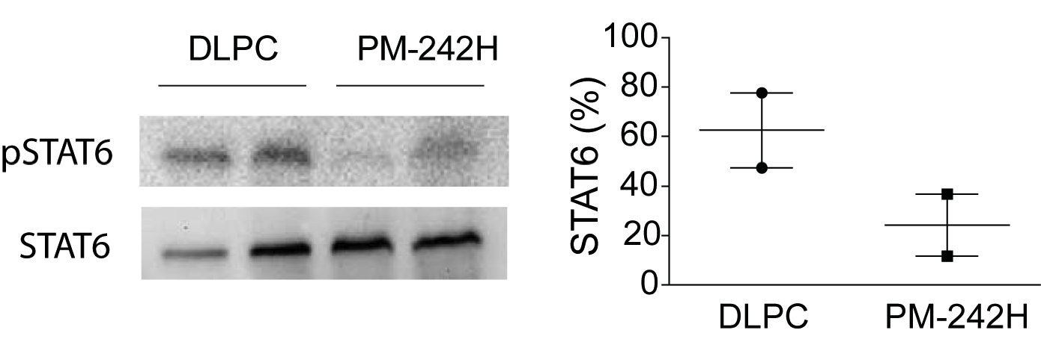
Figure S10. Inhibition of STAT6 activation in vivo. Mice (n = 2) were treated (i.n.) with liposome vehicle (DLPC) or 50 μg PM-242H, allowed to rest overnight and challenged (i.n.) with 3.7 μg recombinant IL-13 for 30 min, after which lungs were harvested, perfused with PBS and phosphorylated and total STAT6 were assessed. Data are from one of 2 independent and comparable biological experiments.

