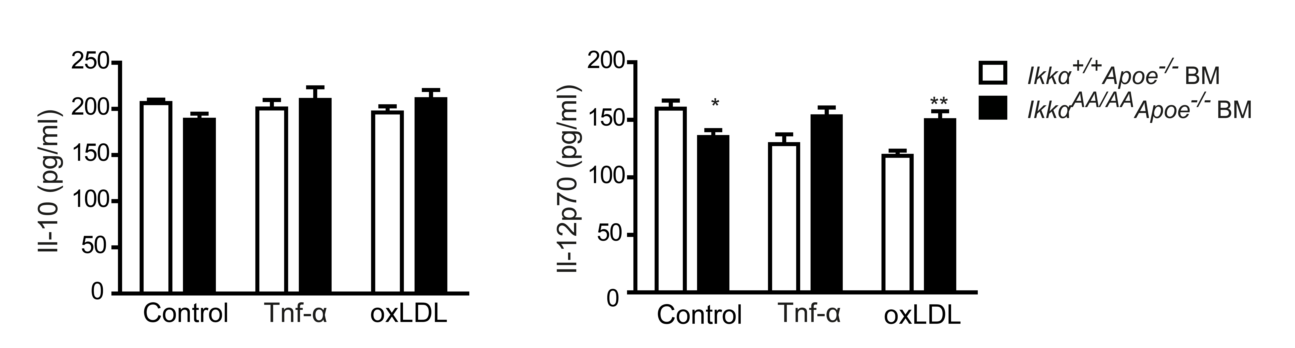
Figure S6. Effect of Ikkα^{AA/AA} knock-in on cytokine secretion from BM-derived macrophages. Shown are cytokine concentrations of Il-10 and Il-12p70 in the supernatants of Ikkα^{AA/AA}Apoe^{-/-} or Ikkα^{+/+}Apoe^{-/-} BM-derived macrophages, unstimulated or after stimulation for 24 h with 10 ng/ml Tnf-α or 50 µg/ml oxLDL, as indicated. Graphs represent mean ± SEM (n=9 from 3 independent experiments); 2-way ANOVA with Bonferroni post-test, *P<0.05, **P<0.01.

