S6 Figure. Differences between years (upper two rows) and locations (lower two rows) within the biodiversity variables per data set (df). Bee count, log-transformed bee count, Shannon diversity and species richness (corrected) are plotted for the bumble bees (bb), solitary bees (sb) and all wild bees (nohb); in each plot the minimum, 1st quartil, median, 3rd quartil and maximum are given. Biodiversity was highly significantly different between locations (p< 0.0001) but less significantly different or non-significant between years (p-values between 0.001 and 0.02) according to Kruskal-Wallis tests.
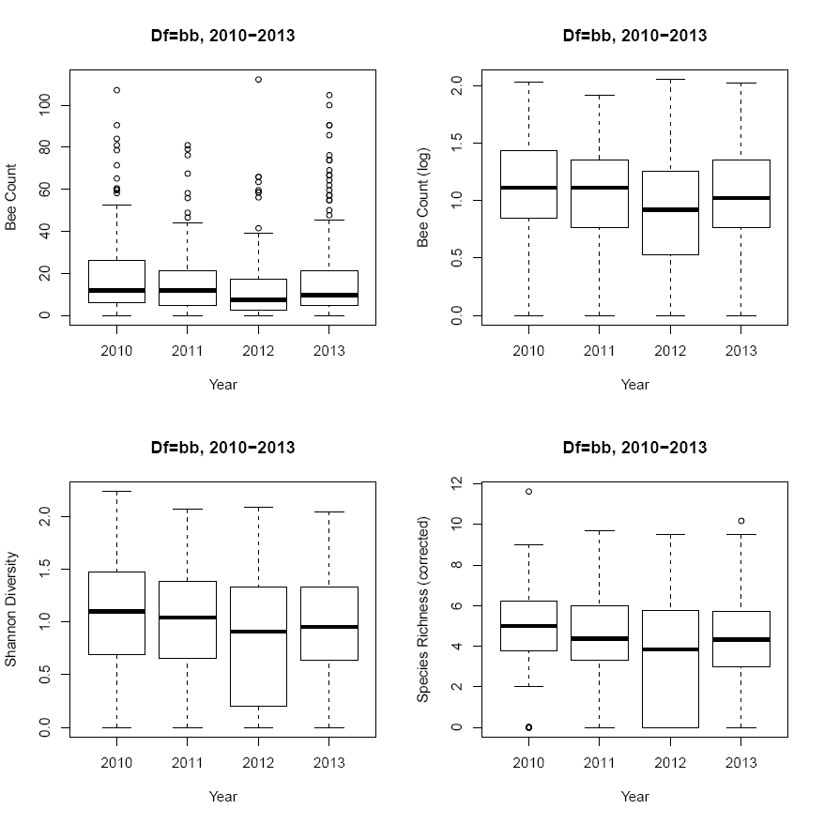 | 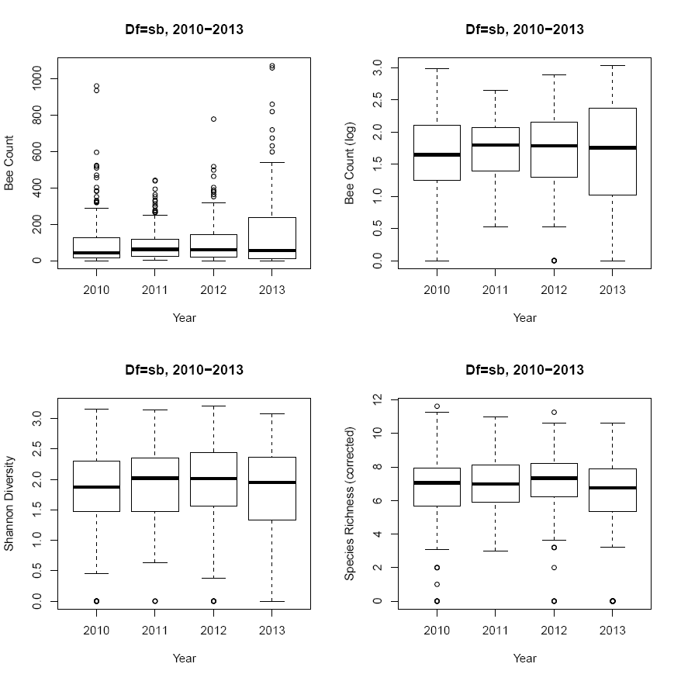 | 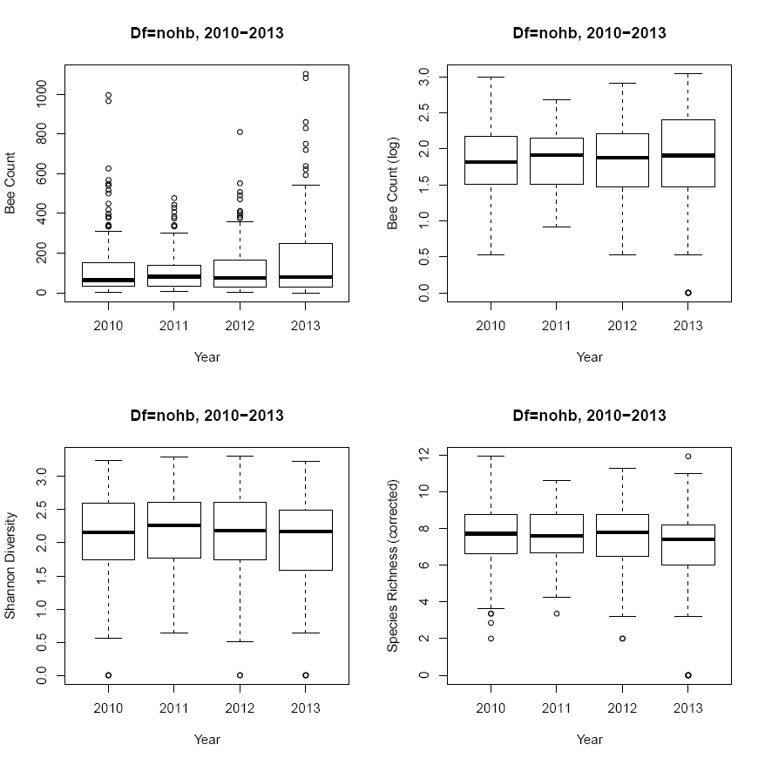
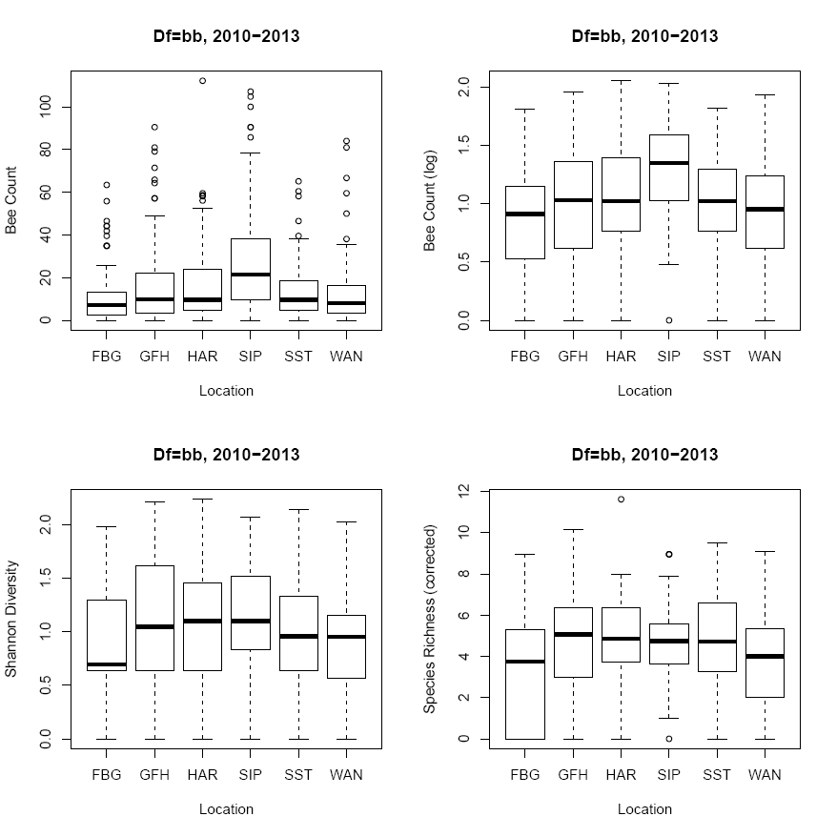 | 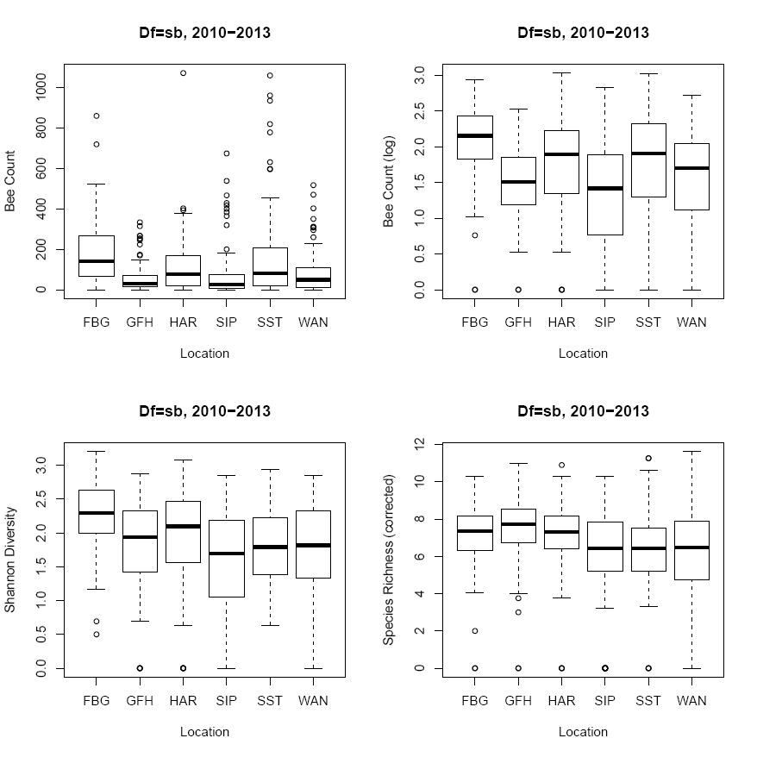 | 