Supporting information

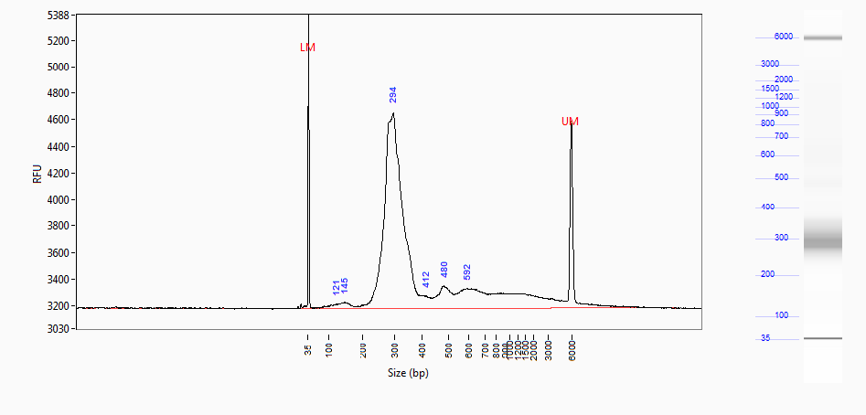

S1 Fig. Profile of the RAD-probes precursor, the RAD-seq library. Left panel, X-axis: fragment size (semi-log scale); Y-axis: fragment density (Relative Fluorescent Units). Right panel : gel-like representation of the left panel.

