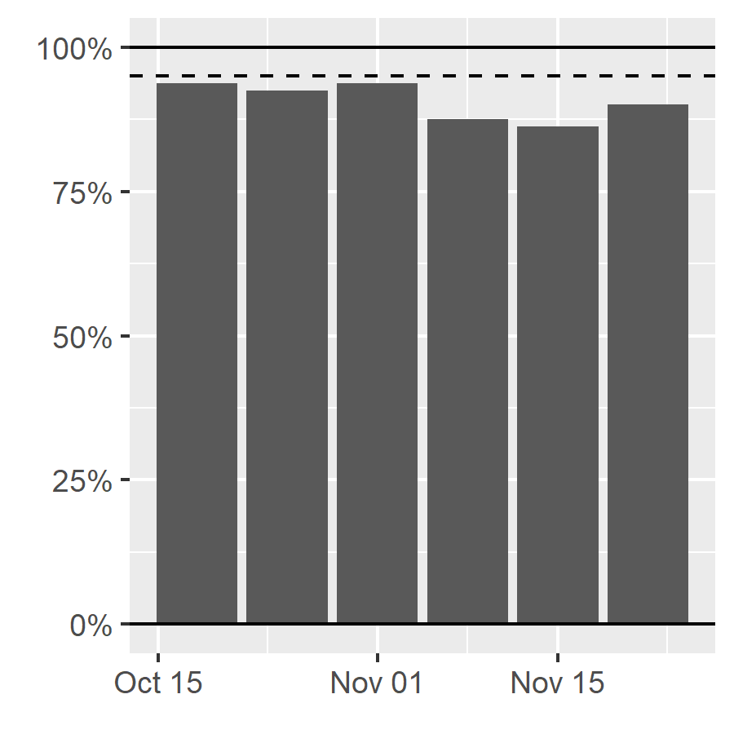

Figure S3. Percentage of weekly reported COVID cases and deaths within 95% interval of out-of-sample predictions from a model using input data up to 6 weeks prior to present.

