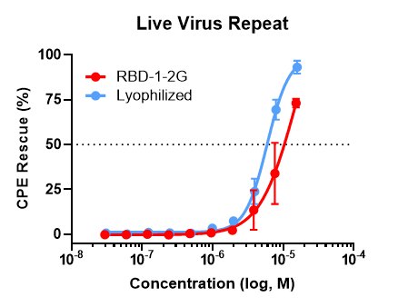
Figure S9: Effect of lyophilization on RBD-1-2G. RBD-1-2G vs a lyophilized reconstituted sample were tested for their ability to inhibit live virus infection. Titration curves with a top concentration of 15.2 µM for the untreated RBD-1-2G and 15.8 µM for the reconstituted lyophilized RBD-1-2G sample. Samples were diluted 1:2 in dPBS before being used for the viral assay. Technical replicates are n = 3 per concentration, all error bars represent S.D.

