Supporting information - Figure S1

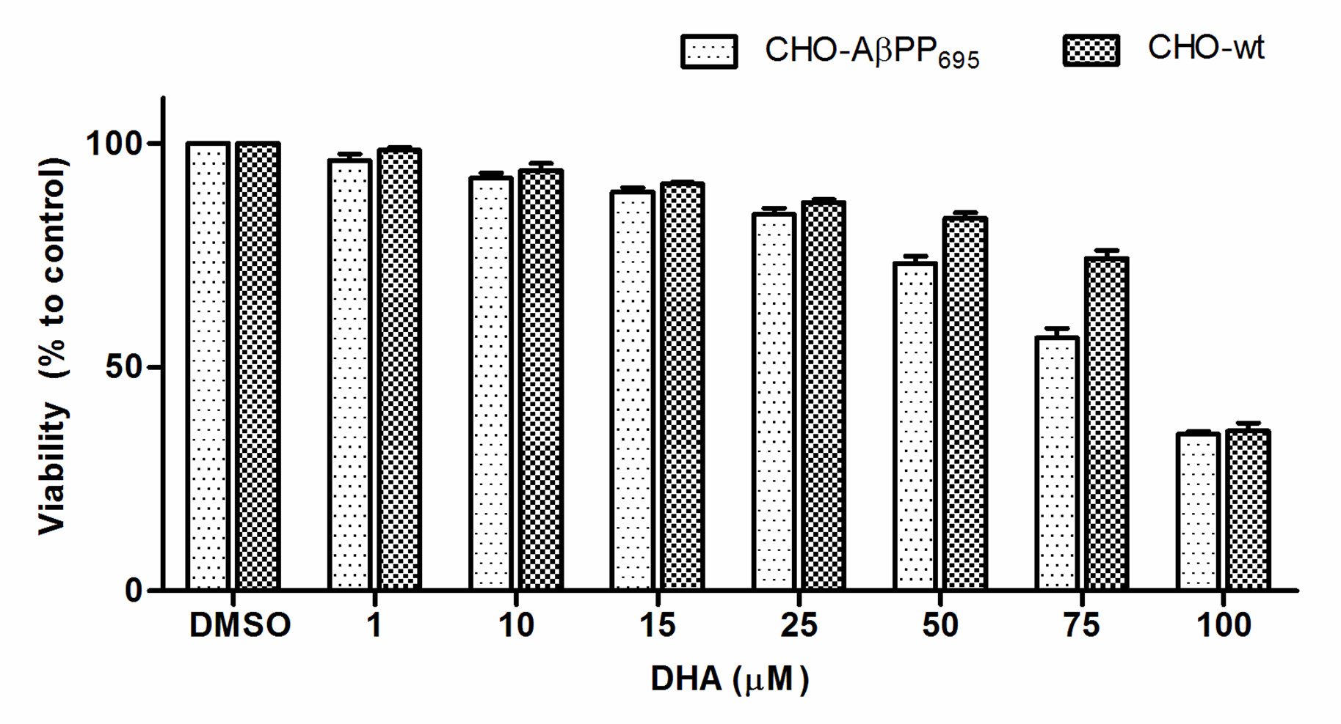

Figure S1: Concentration-dependent effect of DHA on CHO-wt and CHO-AβPP₆₉₅ cell viability over 24 h. The data as derived from three independent MTT experiments repeated in triplicate is presented as mean ± S.E.M relative to DMSO (vehicle control).

