S3 Figure: Network Forest Plot for Primary Safety Endpoint
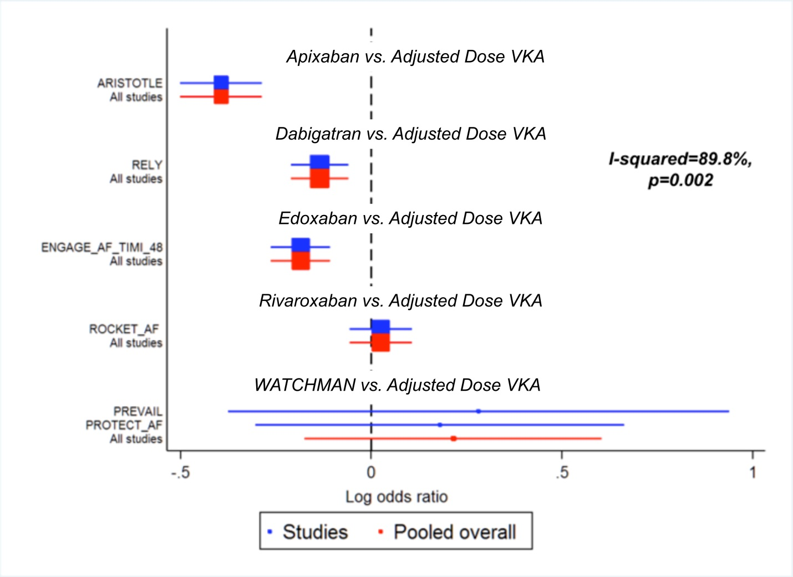VKA = Vitamin K antagonists

