S2 Fig: Relatively symmetric funnel plot suggesting lack of any significant publication bias in the meta-analyses for all the outcome measures viz. acute xerostomia (a), late xerostomia (b), loco-regional control (c), and overall survival (d)
- Acute Xerostomia
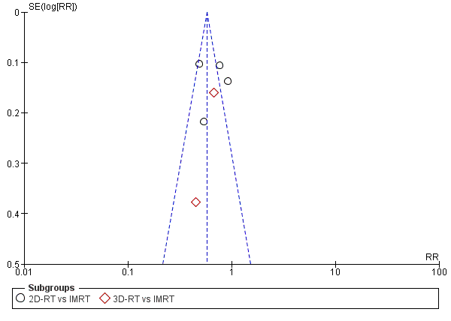

- Late Xerostomia
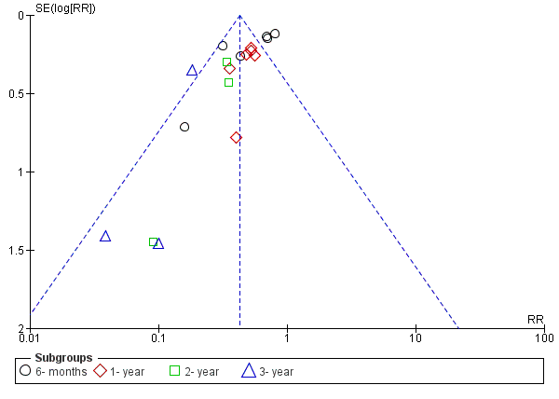

- Loco-Regional Control
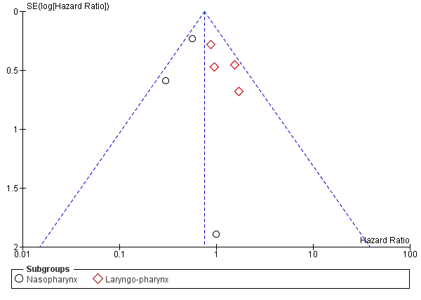

- Overall Survival
