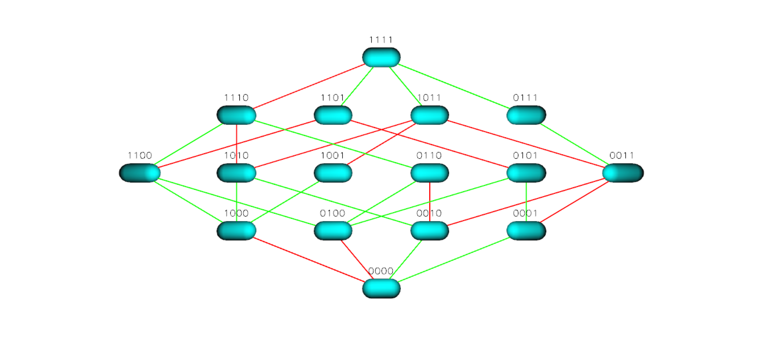
Figure S4 TEM 50 Landscape for Cefpodoxime

