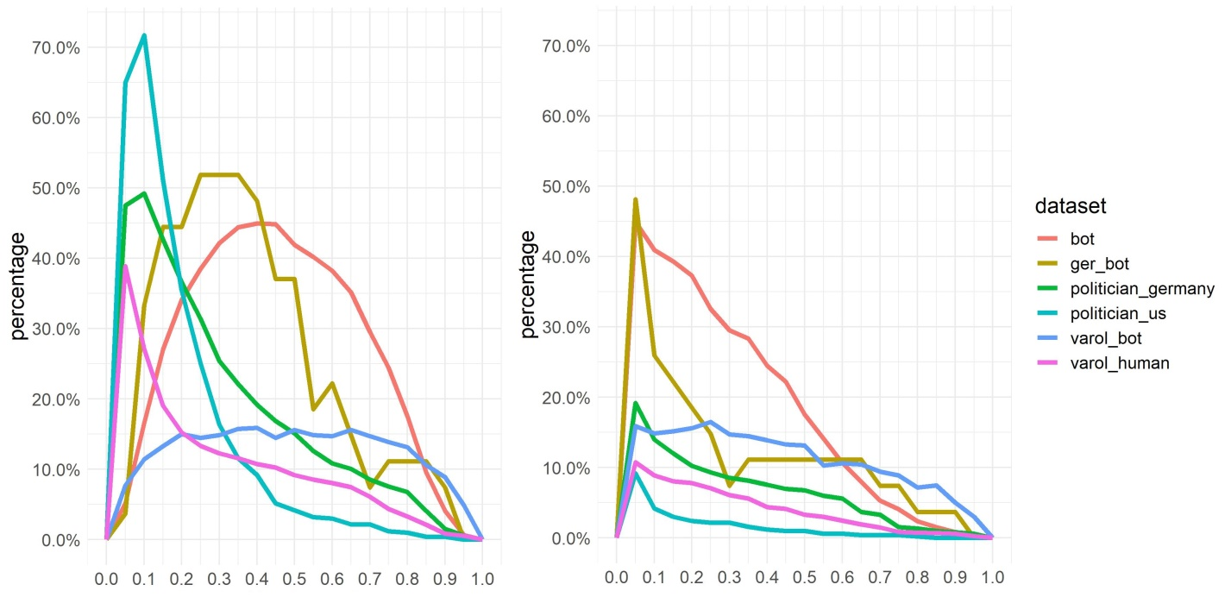
S3 Fig. Changing score over time. Percentage of accounts (y-axis) that have at least once a score in the three months below as well as above the threshold for all thresholds between 0 and 1 in steps of 0.05. Left for the English score, right for the English CAP.

