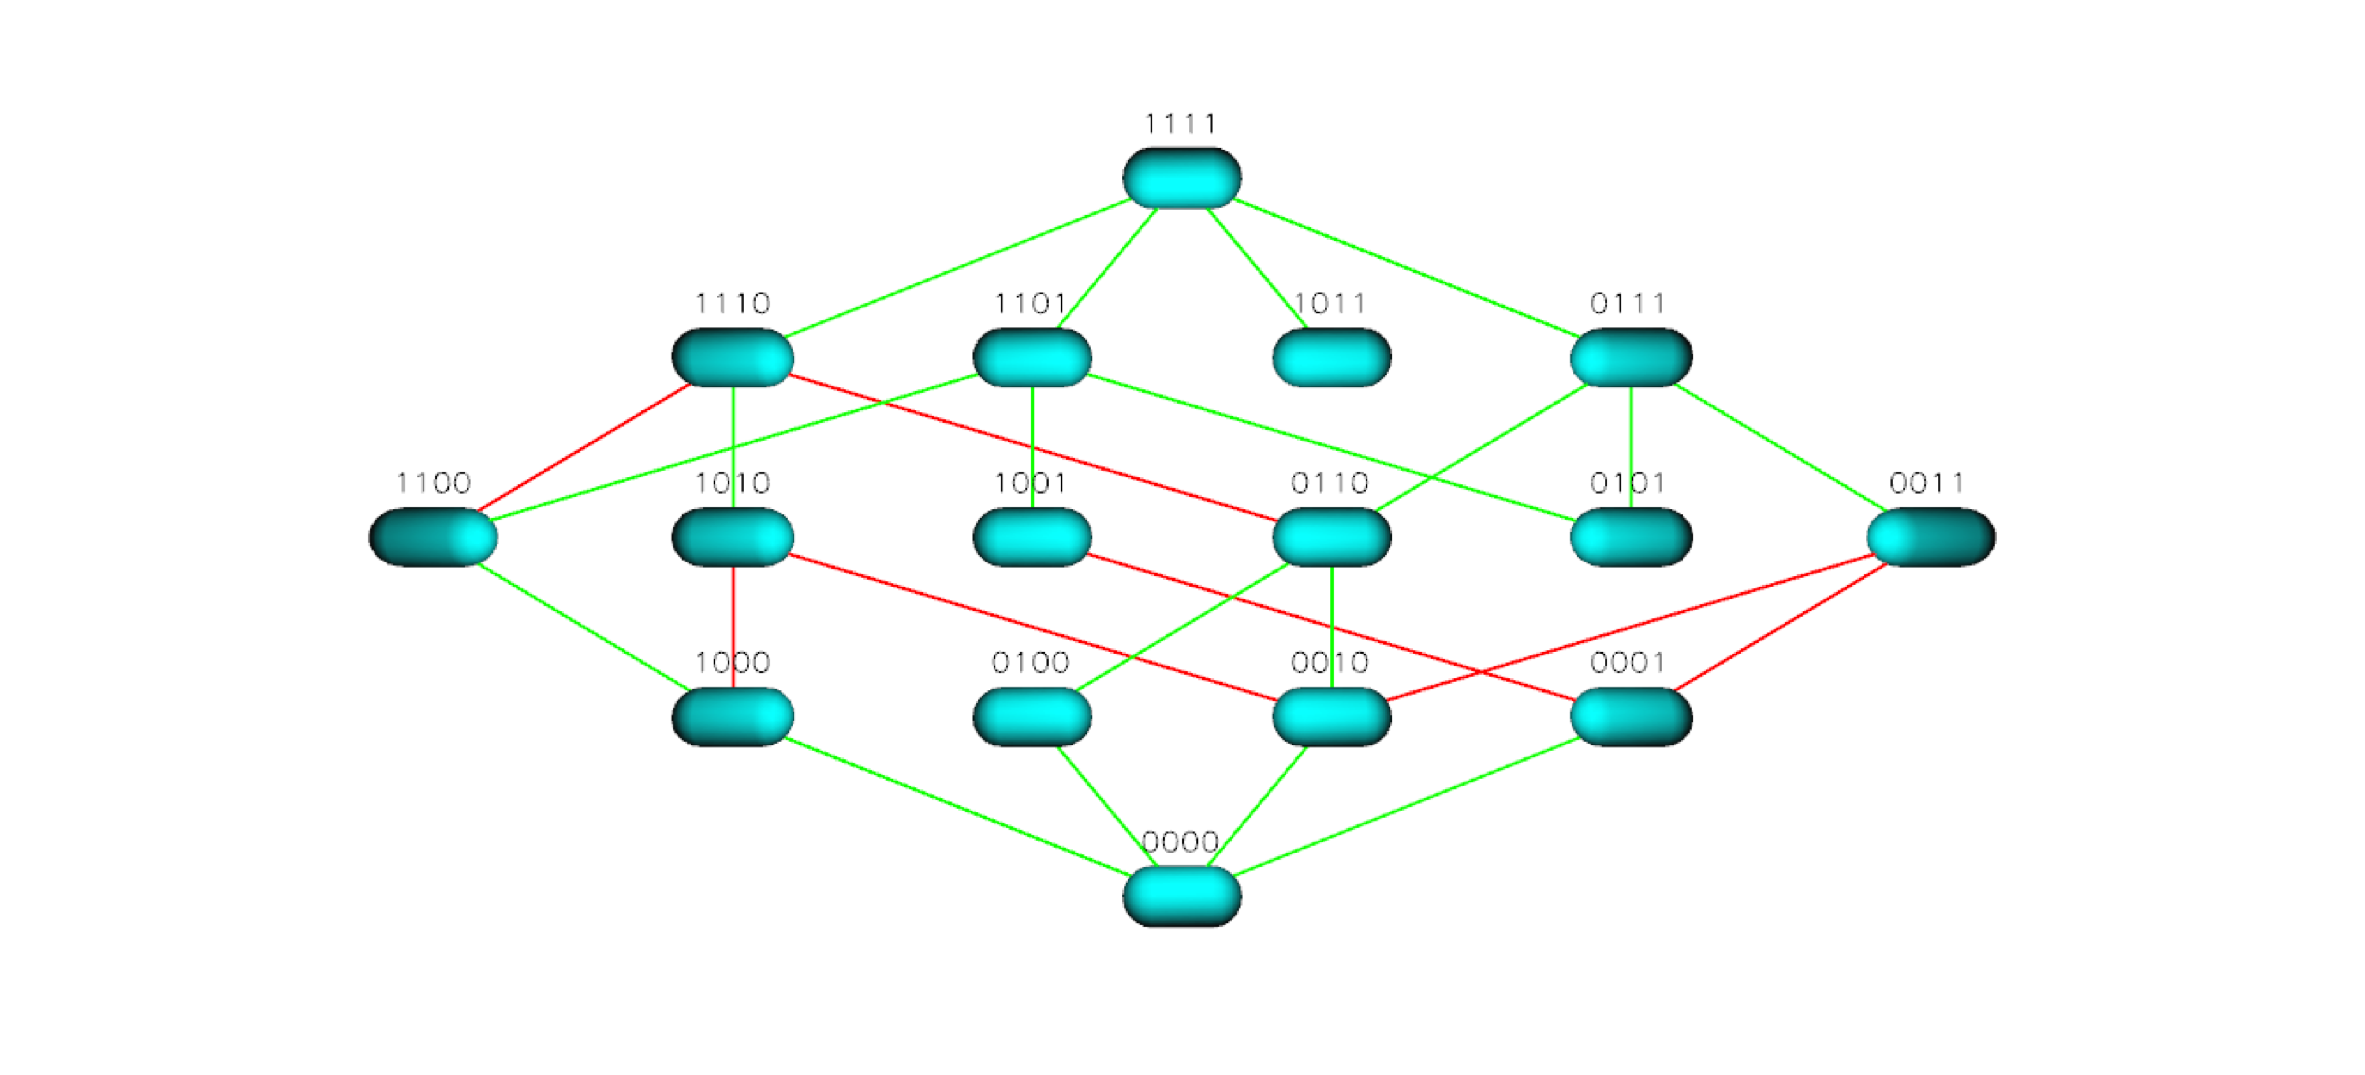
Figure S23 TEM 85 Landscape for Cefotaxime

