S2 Fig. Media articles on the nationwide nurses’ strikes in Uganda during the period of data collection 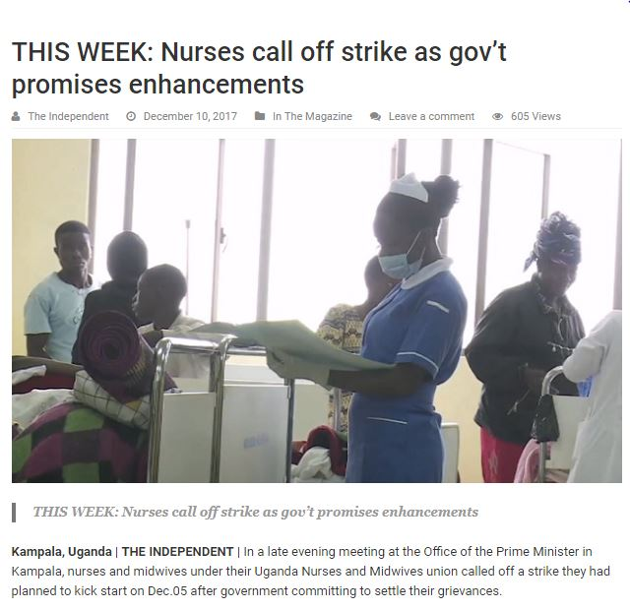
Source the Independent observer
https://observer.ug/news/headlines/56297-nurses-call-off-planned-strike-after-meeting-museveni.html

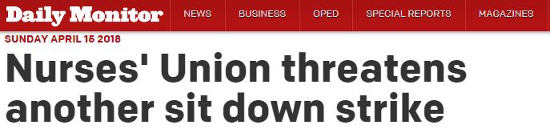
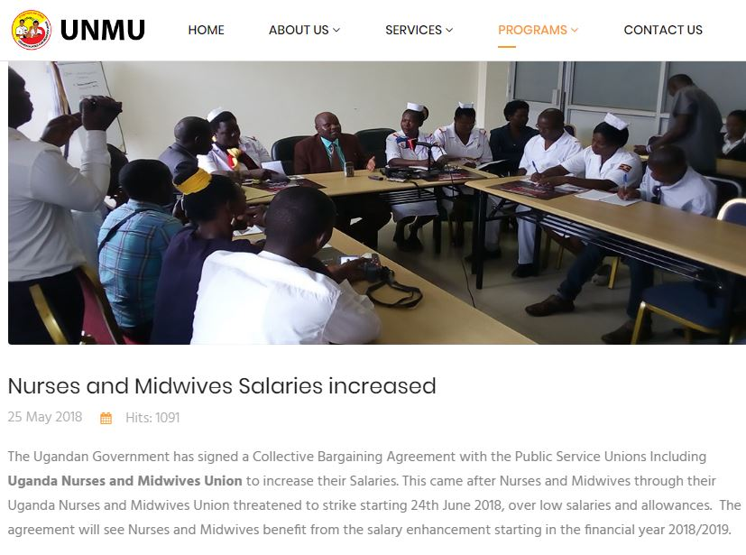Source: the Uganda Nurses and Midwives Union website http://www.unmu.ug/index.php/blog/unmu-calender-events-news/17-nurses-and-midwives-salaries-increased
Other links to videos show the effects of the health worker strikes at Iganga hospital and the end of the nurses strike respectively.
https://www.youtube.com/watch?v=ivI_uUS13AM
https://www.youtube.com/watch?v=lnfvww3O5VM

