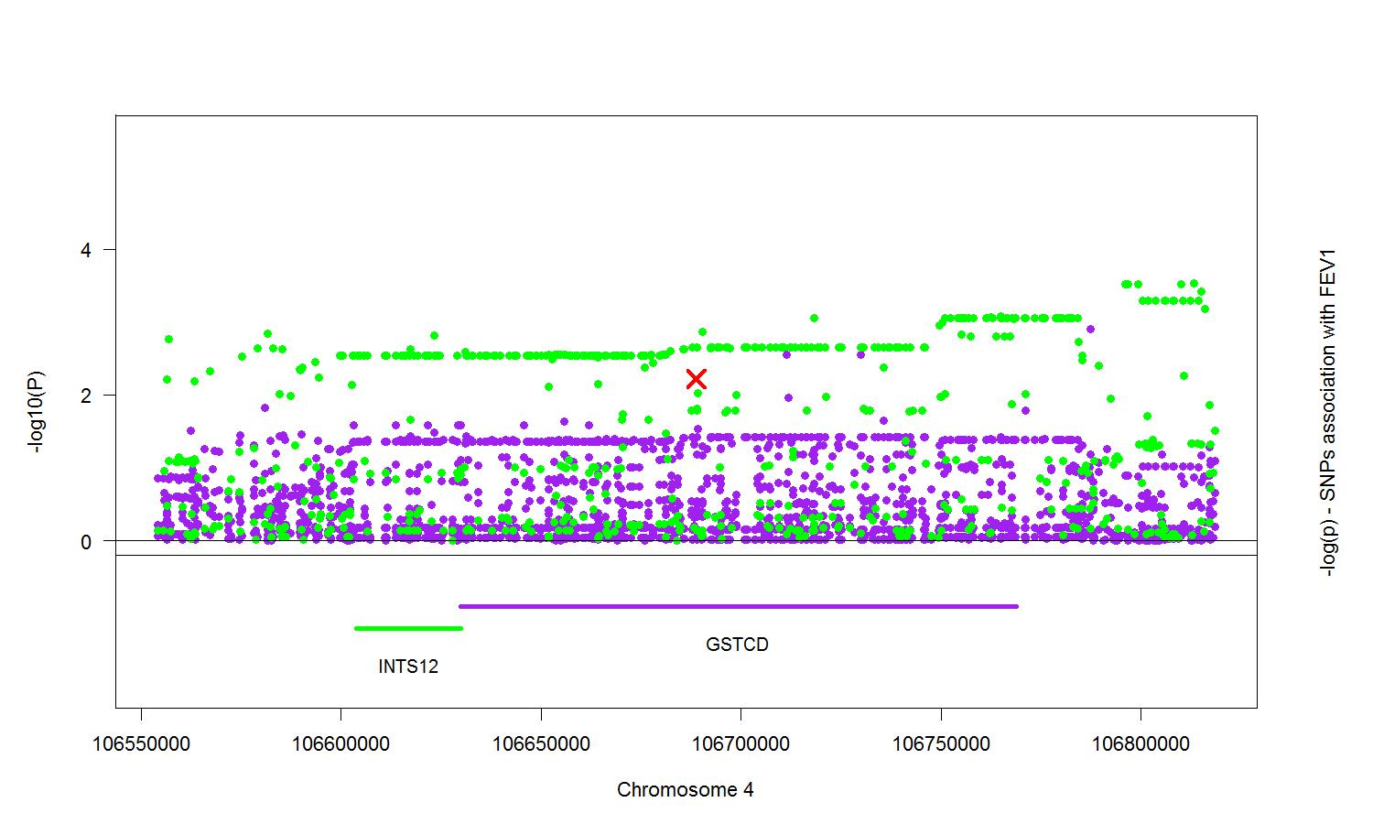

Figure S4. Lung eQTL for GSTCD and INTS12. Shown are the genotyped and imputed Single Nucleotide Polymorphism (SNP) associations with GSTCD (purple) and INTS12 (green) probe sets expression levels in the lungs of 1,111 individuals. The scale on the left side Y axis shows the eQTL –log10 P values, and the scale on the right hand side Y axis shows the FEV₁ association –log10 P values. The red X represents the sentinel SNP rs10516526 for association with FEV₁. The three probe sets for GSTCD were merged into gene level eQTL.

