S2. Wind-hole sites in central Hokkaido, northern Japan.
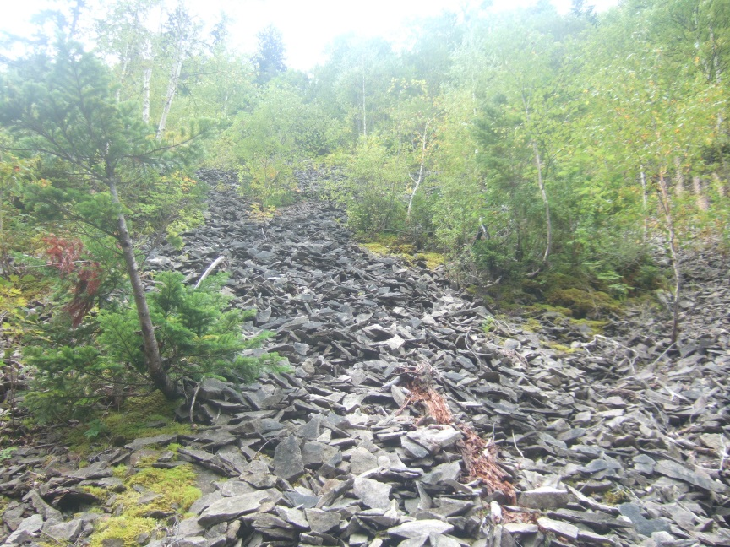
(a)
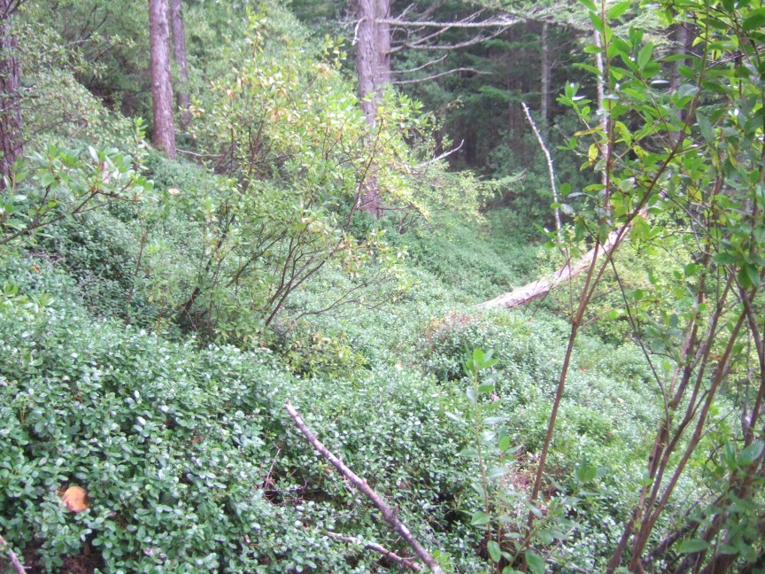
(b)
Wind-hole sites (a) with accumulated rocks and (b) covered by lingonberry.

