S4 Fig. Melting curve qRT-PCR 18S rRNA, survivin, caspase-9, and caspase-3

18S rRNA
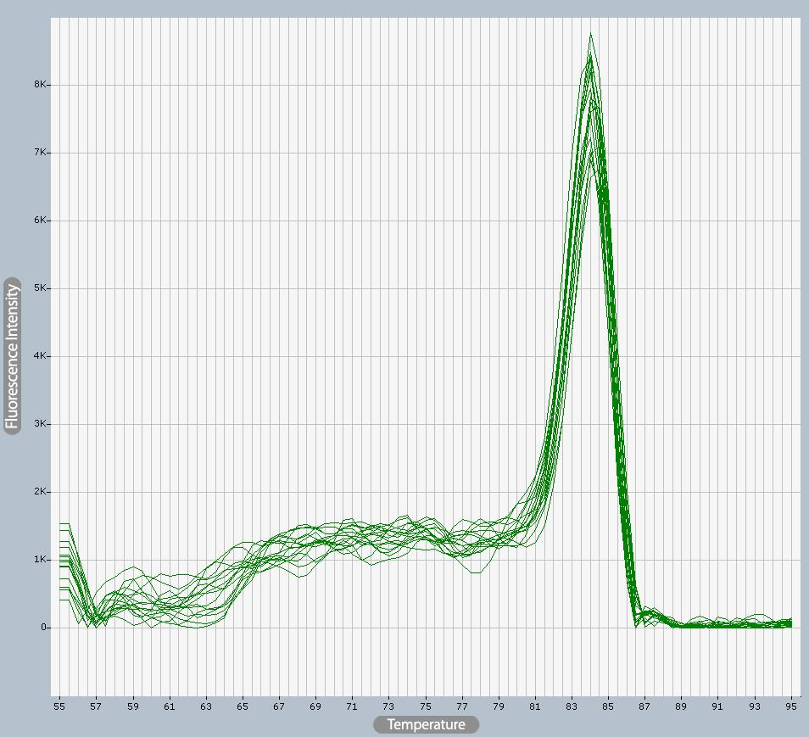

Survivin
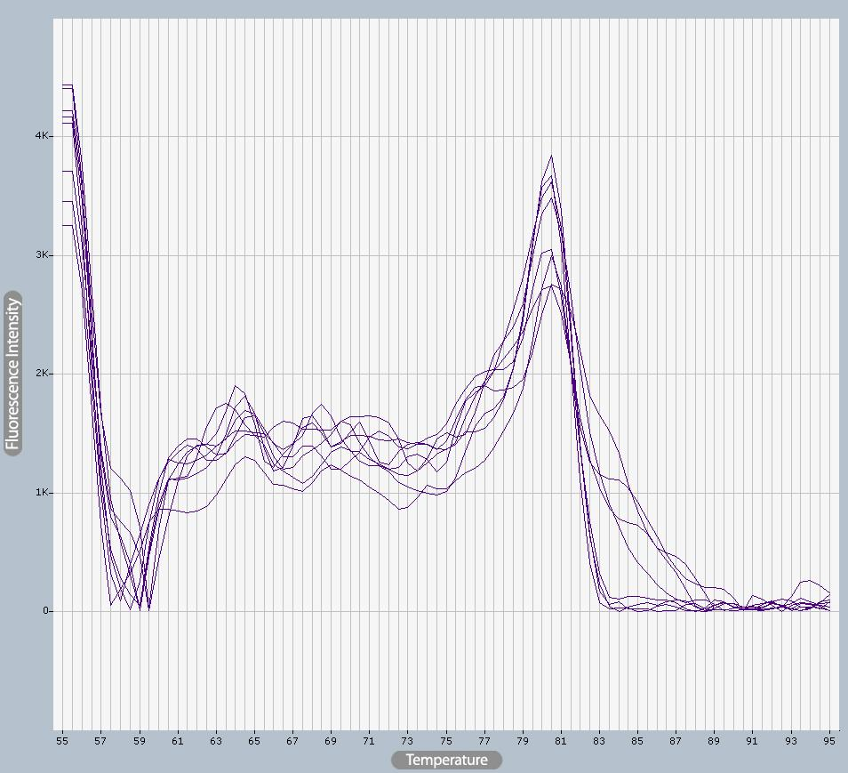
Caspase-9
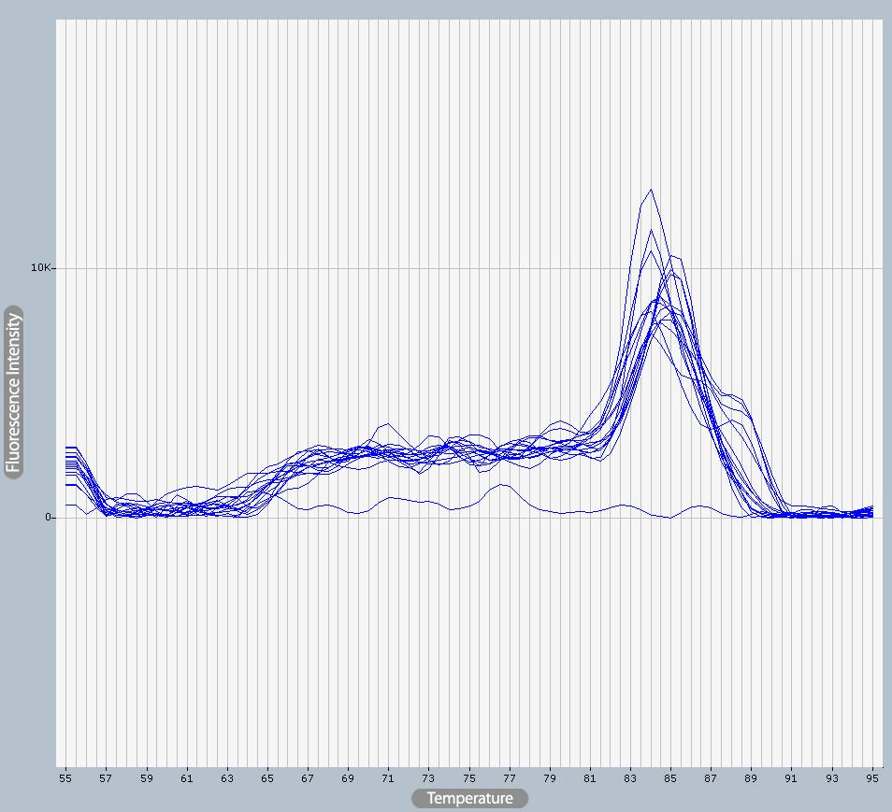

Caspase-3
