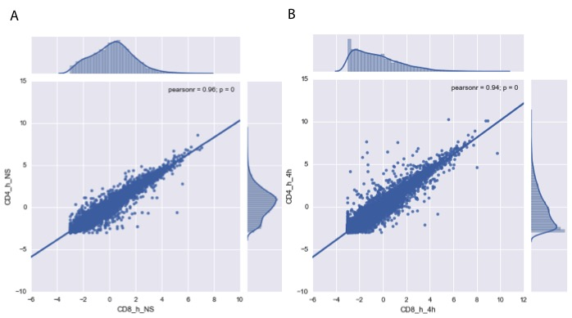
S19 Fig. Correlation of human (A) CD4⁺ and (B) CD8⁺ T cells from the same patient as T₁ increases from 0 hour (NS) to 4 hours.

