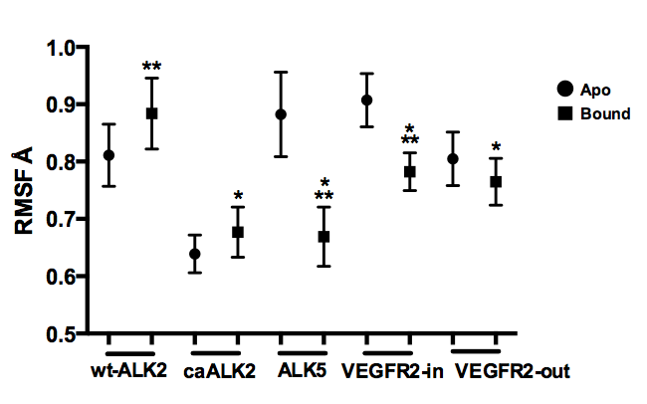

Figure S7. Fluctuation of the A-loop backbone upon DMH1 binding. Statistical differences between the apo and bound conformations are represented by an * above the bound conformation; * =P < 0.05, ** = p < 0.01, and *** = p < 0.001.

