S3 Table. Four exemplary docking calculation results for Oye1 (1OYB) and trans-2-hexenoic acid.
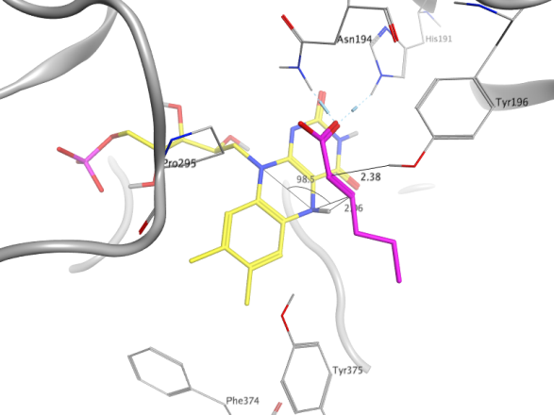 | 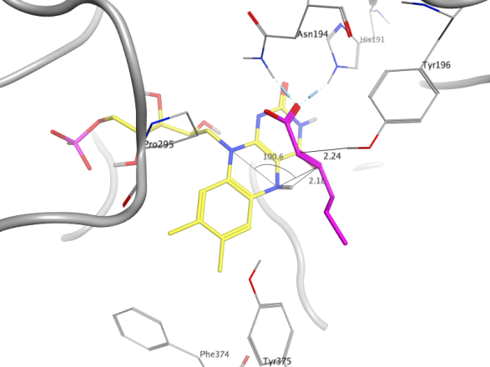
Pose entry 2  Accepted | Pose entry 3  Accepted
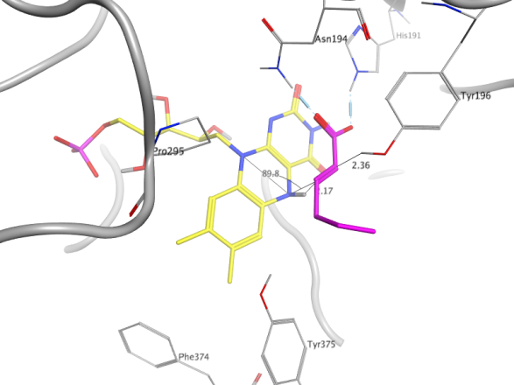 | 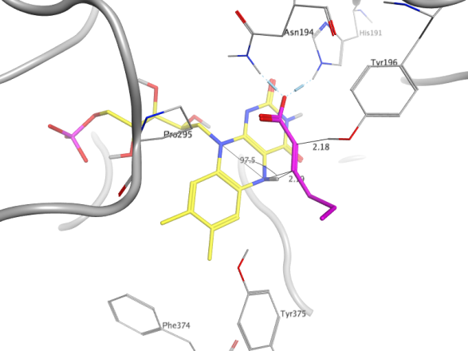
Pose entry 9  Accepted | Pose entry 10  Accepted

