S7A Fig
1 TAACACTTCA GCCATTTTCA CGGCTTCATA AACCTCAAGG GATTTCCCAG AGAAAGACGT 60
61 GTTATTGTCA CAACCAGATC GTGATATCTC GCTTCTTTAC CAATGAGTCC TAACAAAGTA 120
121 GGCATTGAAG CCAAGGTCAA GACCACAATG TCGTTGTGGA ATAGAGCACA ACAGTTACCC 180
181 CAAGACGCGC TTAGGCAGGT TCAAAATGTA TACAATGAAC AGTTCCCCAT CGAAGTGCGA 240
241 CATTACTTGG CTGGATGGAT TGAAGAAAAA ATACATCAGT GGAATGAAAT TGATCCAGAC 300
301 AACCCAGCAC ACAGCCAGTA TGCTCACACT ATCGTATCAC AGCTTATCCA AGAGATGGAA 360
361 AATAAATCAT TGAGCTATGT TAACAATGAA GACCTATTTT TAGTGCGGAT GCGTTTAAAT 420
421 GAAGCTGCTA ATTTATTTAA GACTCGGTAC CTGAATACTA ATCCATTGGC CCTTGTGTCA 480
481 ATCATTCGTA ATTGTCTAAA TACAGAACTT AACCTCGTCC AACAACACGA AAGCATGCTG 540
541 GGTGGCGTAG GGCCAGGTGT AAACATGATC GTTGAACCCT GTACAGAAAT TGTTCAGGAA 600
601 TTAGAGGTGC TGCACAGACG TACCCGGGAA ACTGCAGATG AGTTGCGACA GCTAGAGCAG 660
661 GAACAGGAAT CATTTGCCCT TCAGTACCAT GACTGCGCAA AGATCAATGC TCATTTATCC 720
721 CACATACAAT CACAAGAGAG AACACCACAG AATAGAGATG TGGAAATGAA TTTACGCAAG 780
781 CGAAAAGAAG TTGGGGAGCA ACAGTTAGCA CAAAAGGTTT CTGGGTTATT GCAACGGCGG 840
841 ATGGCGCTAG CAGAAAAACA TAAAGGAACC ATAGACCGAC TCAACAGTTT ACAACAGCGT 900
901 ATTTTAGACG AAGAGTTGAT CAACTGGAAG AGAGAACAAC AAATGGCTGG GAATGGCCGA 960
961 CCTTTCAACC AAAATAAGCT TGATCAAATA CAAGAGTGGT GTGAGGCTCT GGCAGAAATA 1020
1021 ATTTGGCTAA ACCGACACCA AATAAAAGAG TGTGAACGAC ATCAGACCAA GATTCCAATA 1080
1081 GCCCCTCCAG GAGGTGTTGA TATGTTACCA ACCCTCAATT CCCATATCAC TCGTCTTCTC 1140
1141 TCTTCACTTG TTACCAGCAC ATTCATAATA GAGAAACAGC CTCCACAAGT TATGAAGACC 1200
1201 AACACCCGTT TCACTGCTAC AGTGAGGCTA TTGGTTGGTG GAAAGTTGAA TGTAAATATG 1260
1261 ACTCCACCTC AAGTACGGGT GTCCATCATC AGTGAGGCGC AGGCAAATGC TCTCCTAAAG 1320
1321 AATGATCAGA TGAACAAAGG AGAACAGTCG GGTGAAATTC TAAATAATAC AGGCACCATG 1380
1381 GAATACCACC AGGGTACGAG GCAGCTTTCC GTCAGTTTCC GCAATATGCA GTTAAGAAAA 1440
1441 ATTAAACGAG CTGAAAAGAA AGGAACAGAG TCTGTGATGG ATGAAAAGTT TTCGCTTCTT 1500
1501 TTCCAATCAC AATTCAGTGT AGGAGGAGGA GAATTAGTAT TCCAGGTGTG GACGCTATCC 1560
1561 CTACCTGTGG TGGTCATTGT CCACGGTAAT CAGGAGCCAC ATGCTTGGGC AACTGTCTCT 1620
1621 TGGGATAATG CATTTGCTGA ACAAGGTCGC ATACCTTTCA CAGTCCCAGA AAAGGTACCT 1680
1681 TGGCCACAGA TAGCTGAAAT GTTAGACACA AAATTCAAGG CTGCAACTGG CAGGGGTCTT 1740
1741 ACAGAAGATA ACCTGAAGTT CTTAGCAGGC AAAGCCTTTC GTCTTGATAG CTCTCAAGTT 1800
1801 CAAGACTTCA CTAACATGTT GCTGTCATGG TCACAGTTCT GTAAGGAGCC ACTTTCTGAG 1860
1861 CGTAATTTCA CTTTTTGGGA ATGGTTCTTT GCTGTTATGA AGGTAACCAG AGAACACCTT 1920
1921 CGTCAACCTT GGAATGATGG TTCTATCATG GGCTTTGTTG GACGTCGCCC GGCAGAGGAG 1980
1981 ATGCTGAAAA ATTCGAAAAG TGGAACGTTC CTCTTAAGAT TTTCCGACTC AGAATTGGGA 2040
2041 GGGGTTACCA TTGCATGGAT GTATGAAGAT ACTACAAAAG GTGACCAGCG GGATGTCTTC 2100
2101 ATGTTGCAGC CTTTCACAAG CAAGGCTTTT GCAATCCGTC CACTAGCTGA TGTTATTGCT 2160
2161 GACTTGAAGT ATTTGCTCTA TTTATATCCA AATGTGCCTA AAGAGCAGGC ATTTGGAAAG 2220
2221 TACTACACTC CAATGGGAGG AGAGCAGCCC ACAAATAATG GATATGTGAA ACCACATCTT 2280
2281 ATCACTCATG TACCTGGATG GTCAGTGGCT GGAGGGTCGA TGGATTCTTA TCCCAACACA 2340
2341 CCGCAACCTA TGTACCCAAT GCATGACAGC AATATGGGTG ATCCTCCGTC CGTCAGTTCC 2400
2401 AATCCCTCCG ACAGTGTCTC AACAATGCCC CCATACAACG ATACCGATTA TCCTGACATC 2460
2461 TTGGAAAATC TACCAGATAC TGACTTCACT GATATCAACC TTGACTTTCT TCAAACCAAC 2520
2521 TTCATGAAGC CCCAGTAAAA TCAGATGAAG ATTTTTTTTA ATTGTCATAC TGTATATAAG 2580
2581 CATTGTTTAT TGGATAGCCT TGCTTTTAAT ATCTTAGGAT GGTCTTTAAT TGAATTTTGC 2640
2641 ATTTAAAAAG GCAAAGAAAA AGAAGAGTGT ATTTTCAGAG GATGATGTGT AACCATAGTG 2700
2701 TCTTAGGGGT ATGCTTTAAT GTTAGGTGAA TATGAAATCG TTGTTACAAG AATTCTGCAA 2760
2761 ACGTGTATGT AGGAATTACC TTTCTCATAG ATCTTATATA AAAATGTTAA AAGGATTTCA 2820
2821 GAAATATAGC TTCATGTGTT TGATTCAATT TACAAATCAC TTAAATACAC AAAACTATTT 2880
2881 GCATTAACTG GCAAAATTTA ATCAAA 2907

S7B Fig
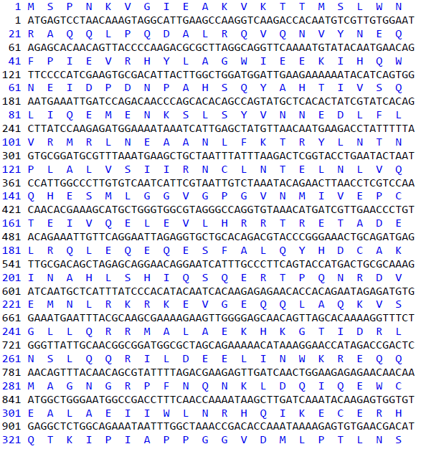

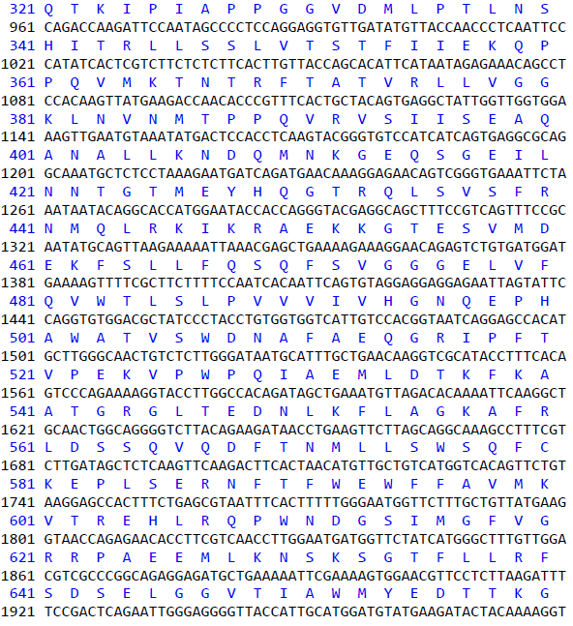
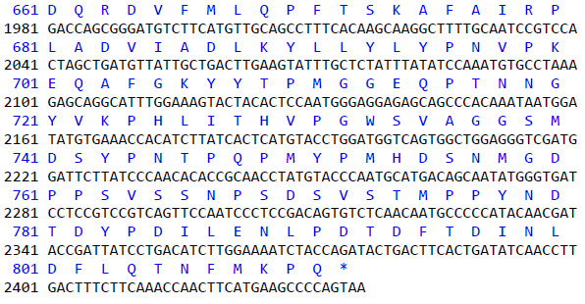

S7 Fig

