S1 Fig. Variables Principal component analysis
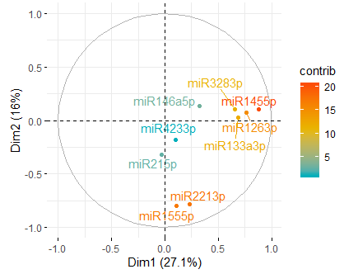
Positive correlated variables point to the same side of the plot. Negative correlated variables point to opposite sides of the graph.

