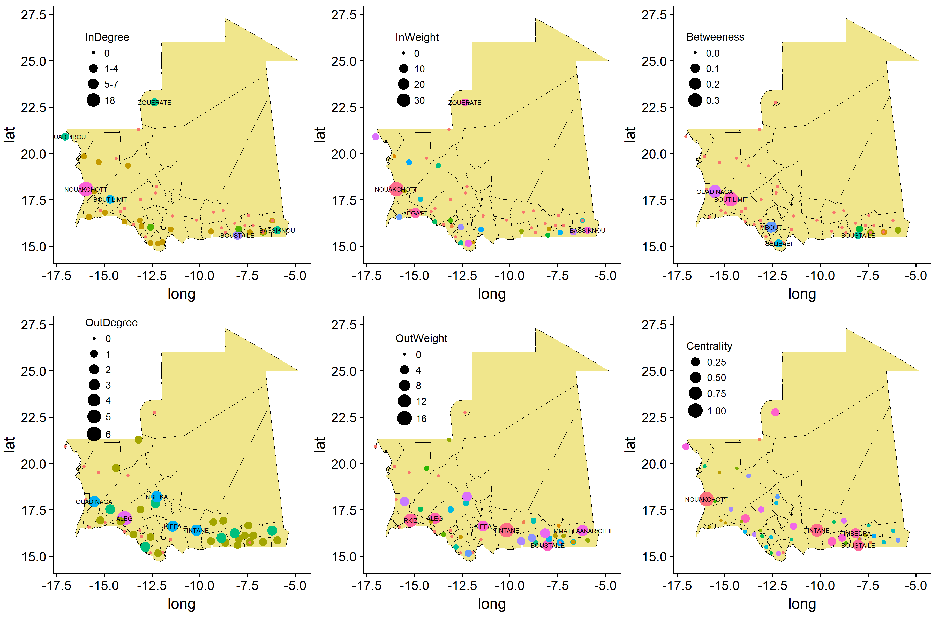
SI Figure 1. Small ruminant trading network and related centrality measures for Mauritania in 2014. Node size show the importance of the measured centrality values. in and out-weight measures were scaled on the total volume of traded livestock; eigenvector centrality (centrality measure) were scored from 0 to 1, betweenness was considered for the fraction of paths passing through the node.
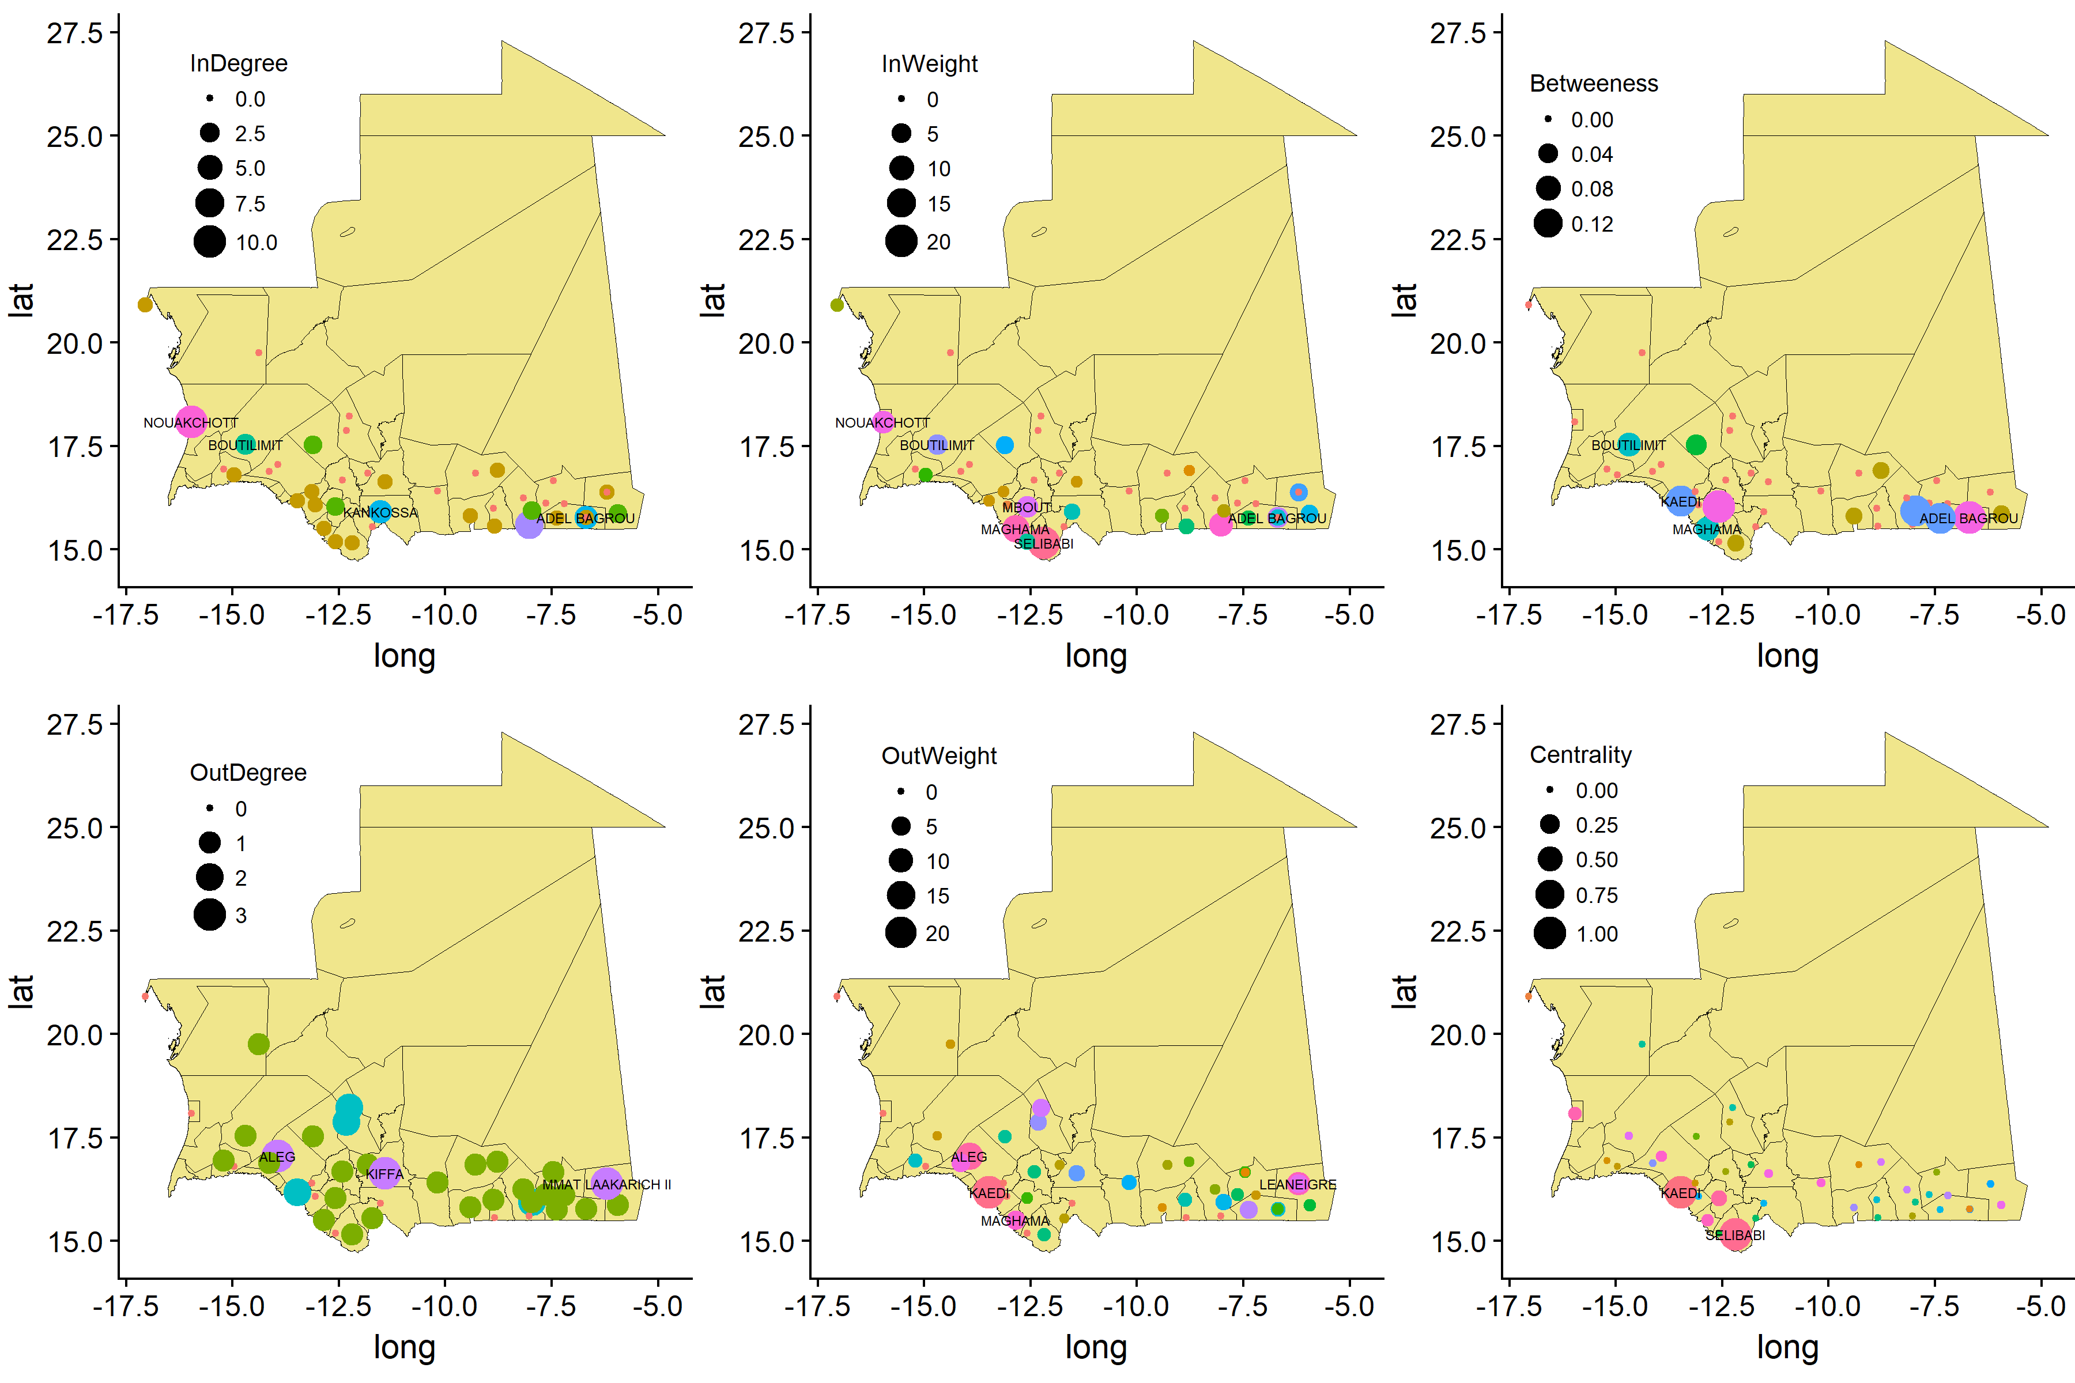SI Figure 2. Cattle trading network and related centrality measures for Mauritania in 2014. Legend were kept as in SI Figure 1.
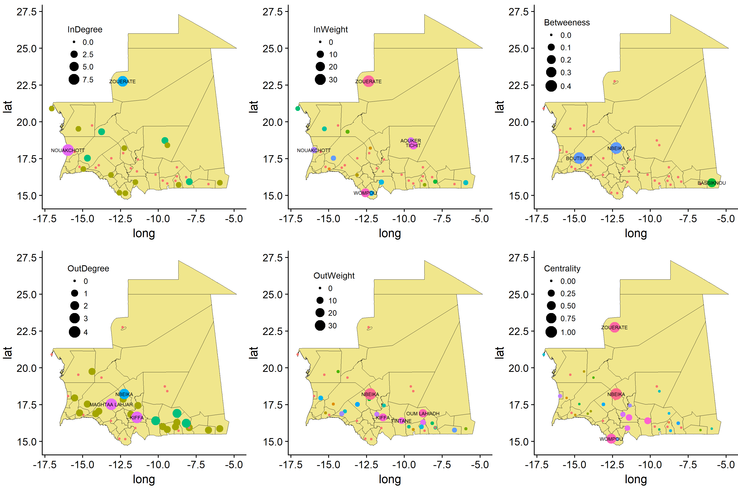SI Figure 3. Camel trading network and related centrality measures for Mauritania in 2014. Legend were kept as in SI Figure 1.

