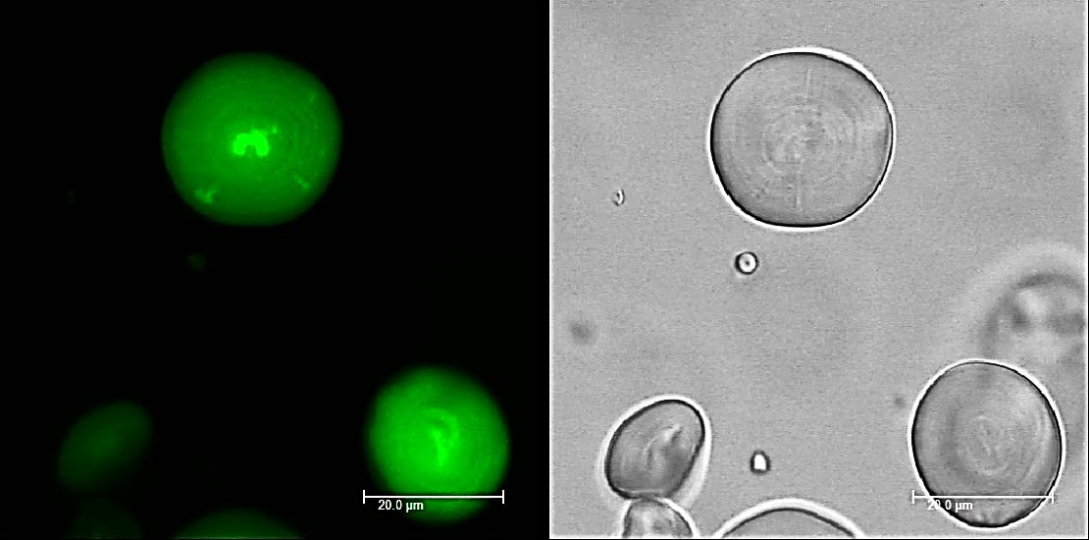

S6 Fig. Confocal laser scanning micrograph of HP starch granules indicating protein filled bright channels in purified starch granules stained with APTS. Scale bar indicates 20 µm.

