MALAWI

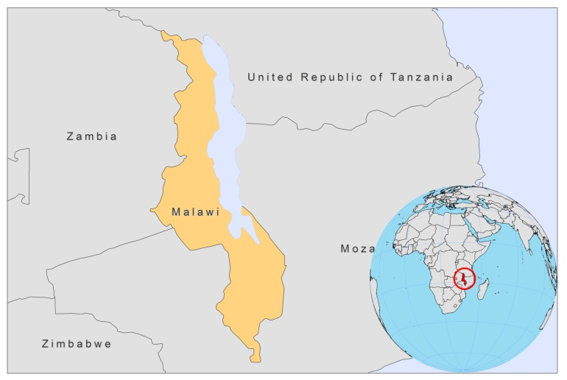

BASIC COUNTRY DATA

Total Population: 14,900,841
Population 0-14 years: 46%
Rural population: 80%
Population living under USD 1.25 a day: no data
Population living under the national poverty line: no data
Income status: Low income economy
Ranking: Low human development (ranking 171)
Per capita total expenditure on health at average exchange rate (US dollar): 19
Life expectancy at birth (years): 53
Healthy life expectancy at birth (years): 35

BACKGROUND INFORMATION

Leishmaniasis is rare in Malawi. The first case of autochtonous VL caused by L.donovani was reported in 1979 in a 38-year-old male [1].

Leishmaniasis was diagnosed -post mortem- in 2 cases in Northern Malawi [2]. One was suspected VL in an 18-months-old malnourished child, with wide spread rash, in 1989; the other was CL in an HIV-1 positive adult, with skin lesions that had been present for 6 months, in the late 1990s. Both patients had a history of travel to the United Republic of Tanzania. No further cases have been documented.

PARASITOLOGICAL INFORMATION

Leishmania species | Clinical form | Vector species | Reservoirs
Unknown | VL, CL | Unknown | Unknown

MAPS AND TRENDS, CONTROL, DIAGNOSIS, TREATMENT, ACCESS TO CARE, ACCESS TO DRUGS

No information available.
No antimonials are registered.

SOURCES OF INFORMATION

1. Knowles JK, Paul B, Hutt MS, Lucas S (198). A case of visceral leishmaniasis in Malawi. Trans R Soc Trop Med Hyg 75(3):474-5.

2. Pharoah PD, Ponnighaus JM, Chavula D, Lucas SB (1993). Two cases of cutaneous leishmaniasis in Malawi. Trans R Soc Trop Med Hyg 87(6):668-70.

