Supplementary Figure S1. Restriction digestion of PCR products by BamHI.

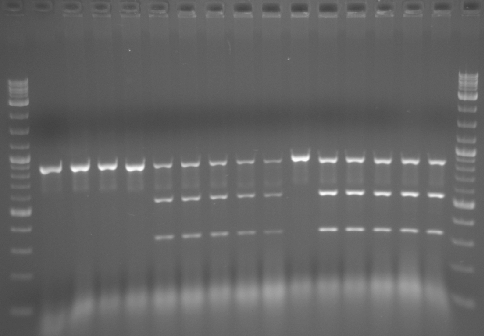
317 bp
546 bp
880 bp
17
16
15
14
13
12
11
10
7
9
8
5
4
6
3
2
1

Figure S1. Result of BamHI restriction digestion following colony PCR. The TRP5 locus was PCR amplified from Trp⁺ colonies formed after transformation of cells expressing wild-type (SAS-78) or K223I (SAS-148) I-SceI without or with the TRP5.80F and TRP5.80R complementary pair of oligonucleotides, which introduce a silent mutation generating a BamHI site upon recombination into the trp5 locus. The PCR product (~880 bp) was then digested with BamHI. Lanes 1 and 17, 2-log DNA ladder (NEB). Lane 2, undigested PCR product. Lane 3, uncut PCR product deriving from Trp⁻ SAS-78. Lanes 4 and 5, uncut PCR product deriving from Trp⁺ transformant clones of SAS-78 expressing wild-type I-SceI and transformed with no oligonucleotides; lanes 6-10, cut PCR product deriving from Trp⁺ transformant clones of SAS-78 expressing wild-type I-SceI and transformed with TRP5.80F and TRP5.80R. Lane 11, uncut PCR product deriving from Trp⁻ SAS-148. Lanes 12-16, cut PCR product deriving from Trp⁺ transformant clones of SAS-148 expressing K223I I-SceI and transformed with TRP5.80F and TRP5.80R. The PCR products that are digested and cut by BamHI into 546-bp and 317-bp bands still retain uncut product; this is due to the fact the PCR product is directly digested without being first purified.

