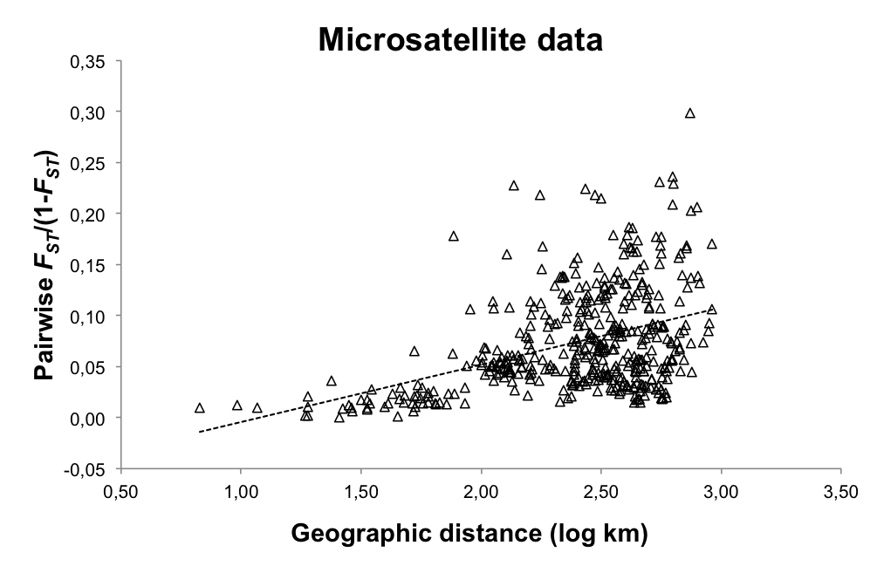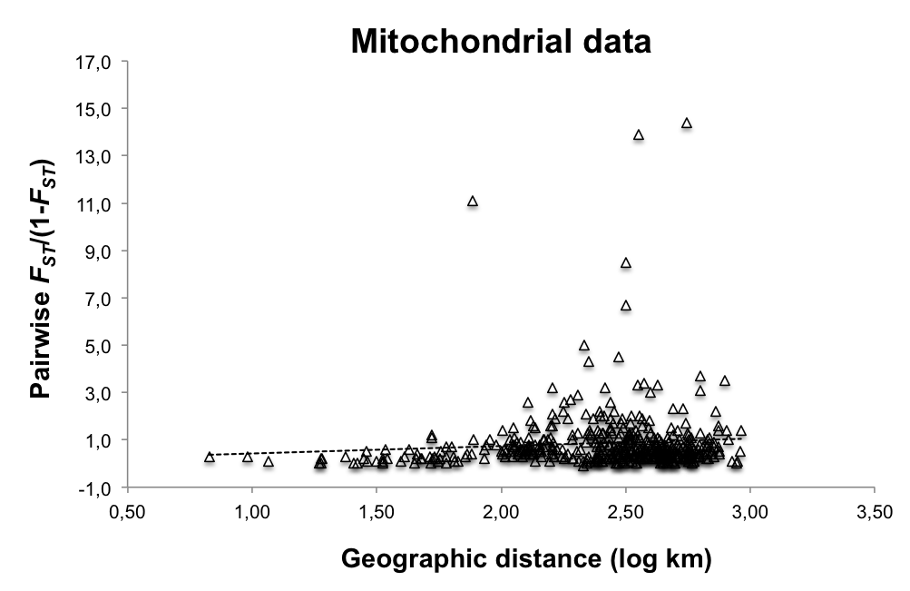

S3 Fig. Plots showing the relationship between the genetic distance [pairwise F_{ST}/(1-F_{ST})] and geographic distance (log km) between the Iberian red deer populations quantified for both microsatellites and mitochondrial datasets (isolation-by-distance).

