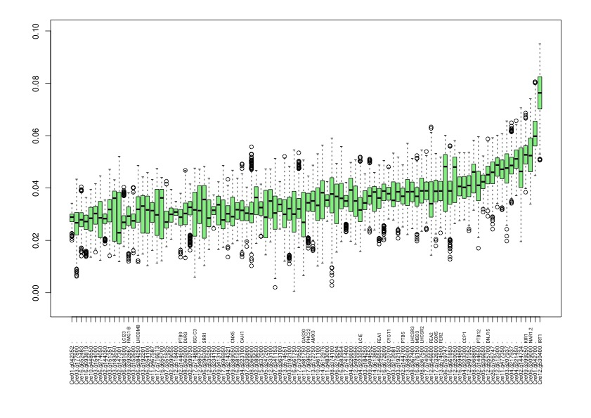

S6 Fig. Distribution of G₂ values of the first hundred genes contributing most to the light-grown samples. Data are computed from 1000 random combinations of 14 samples.

