S8 – Prediction of Learning and Behaviour from DHA omega-3 change scores

The DOLAB II study used objective blood fatty acid measures to estimate adherence to the intervention. These also allow examination of changes in blood DHA levels to predict learning and behaviour outcomes. The relationship of the changes in DHA levels with the primary outcomes is assessed below using scatterplots with non-parametric (LOWESS) curves to visually inspect any relationship. – For reading and working memory an upward curve indicates positive relationship between changes in DHA levels and the outcomes, whilst downward curves for the behavioural outcomes indicate improvements in behaviour i.e. a reduction in behavioural problems.

Reading
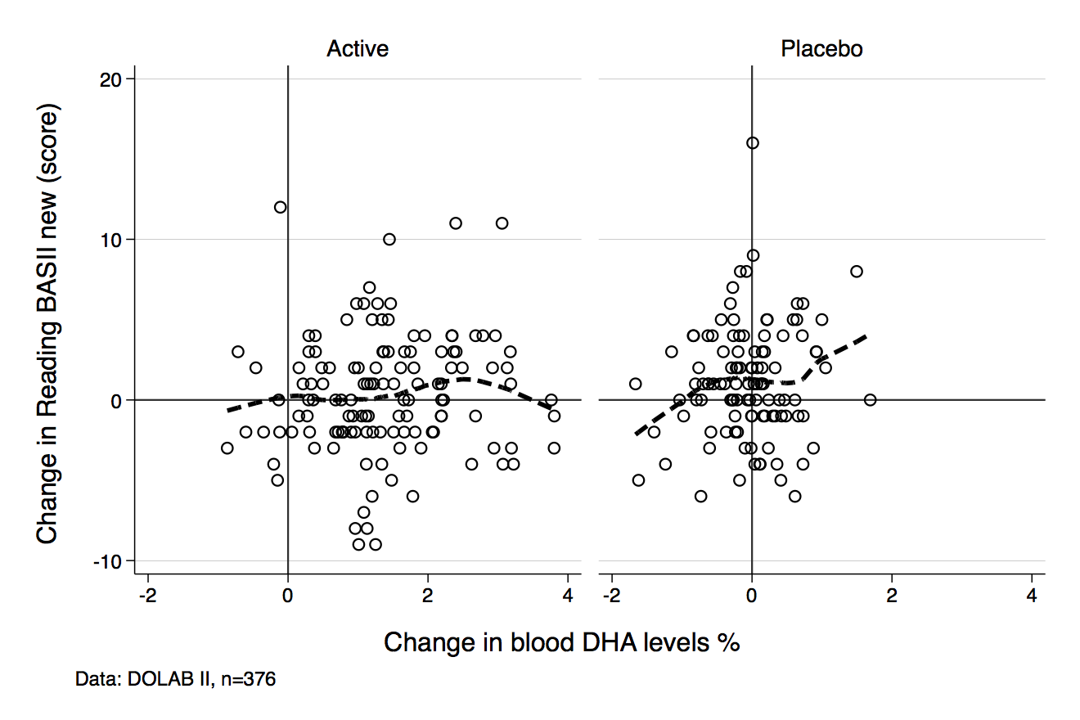

Working Memory
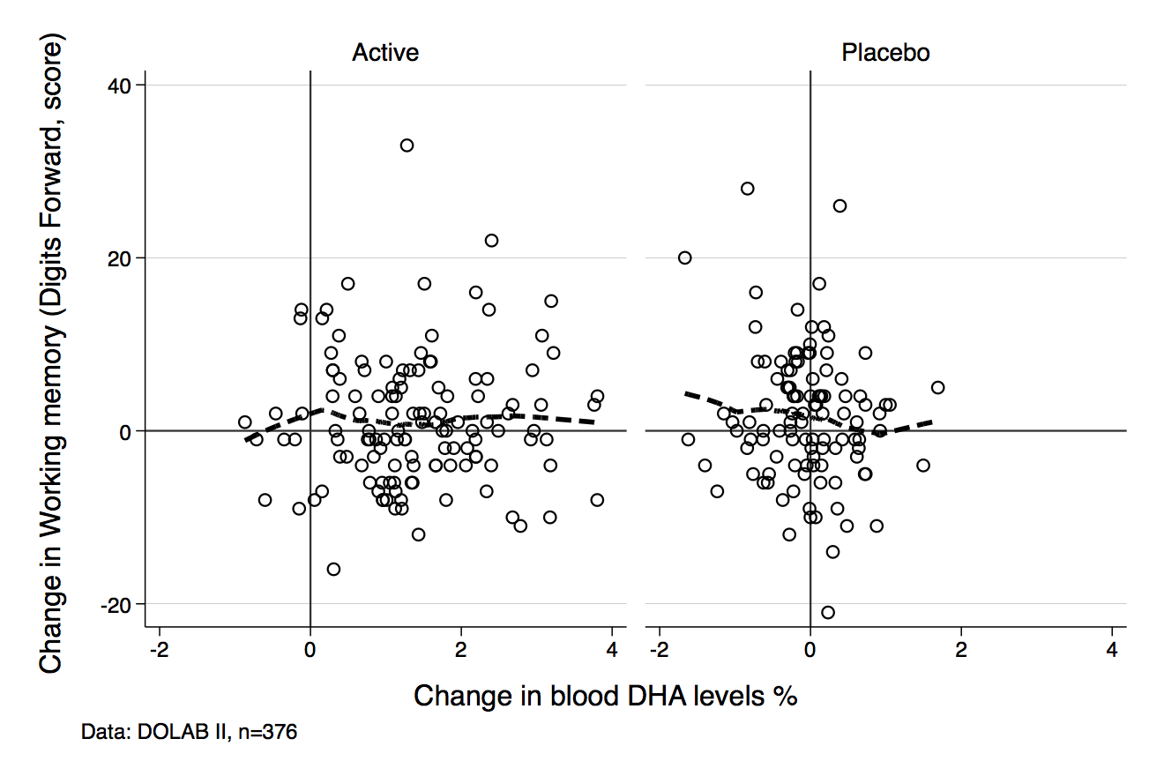
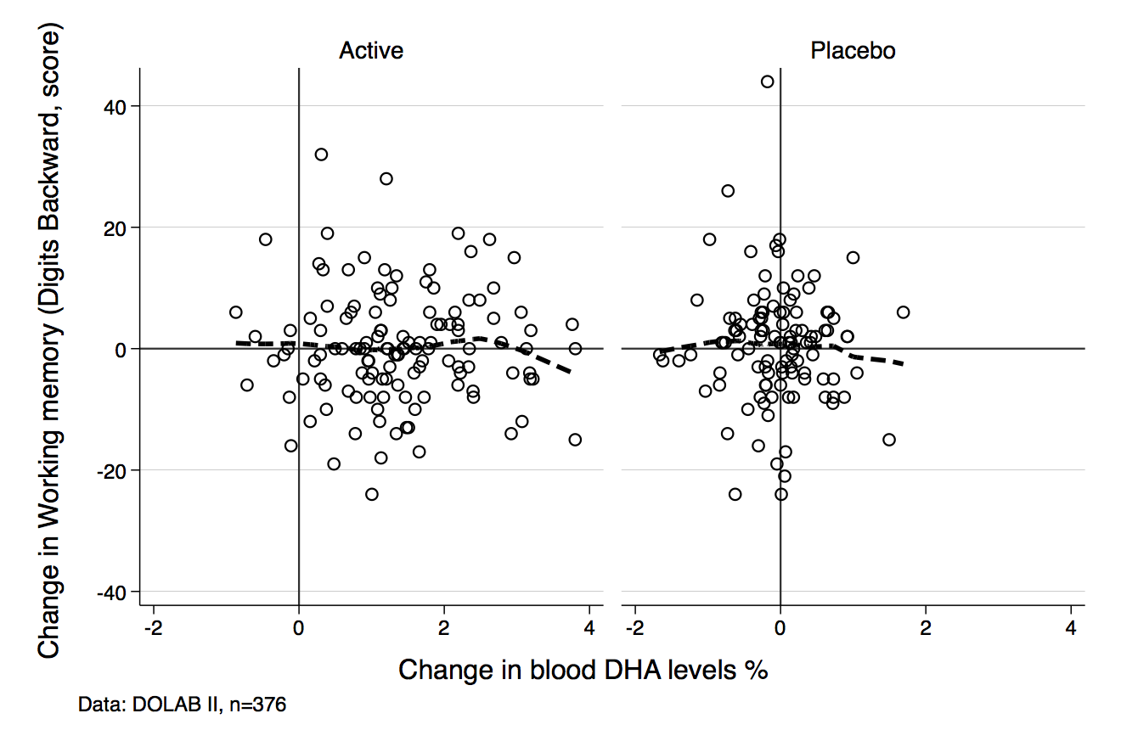

Change score: Parent Oppositional T score
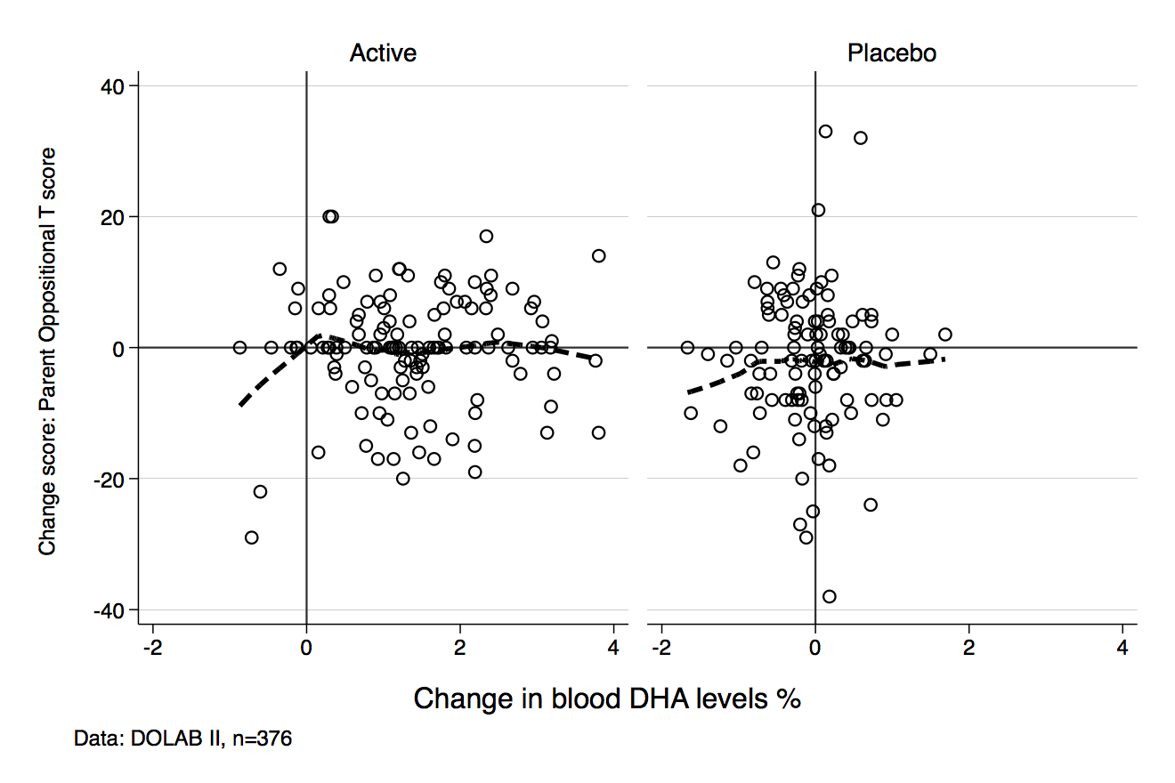

Change score: Parent Cognitive Problems/Inattention T score
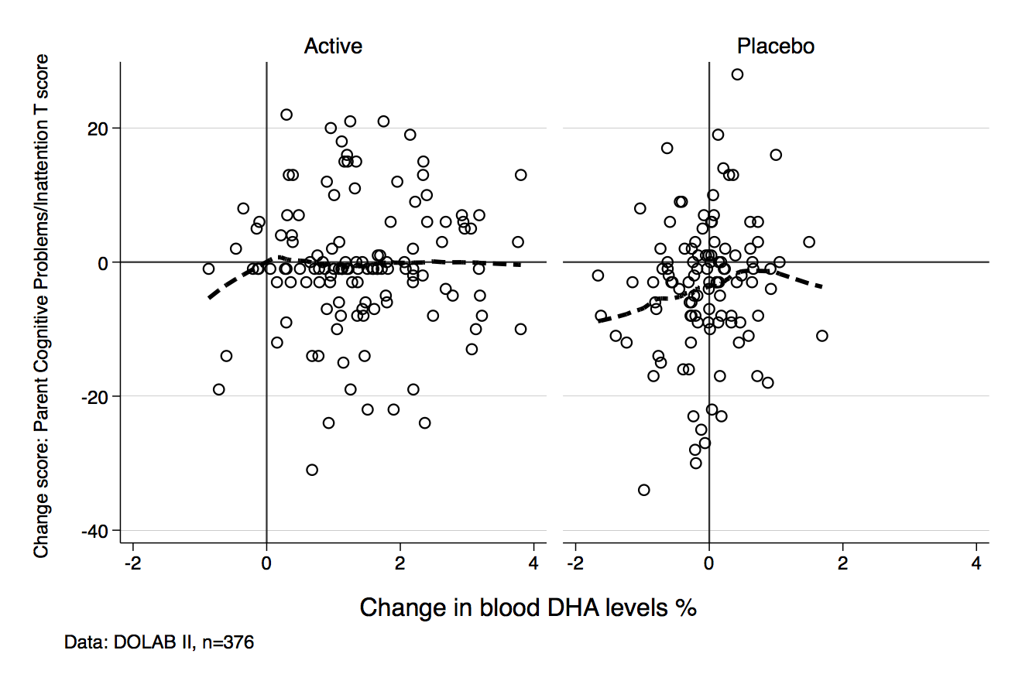

Change score: Parent Hyperactivity T score
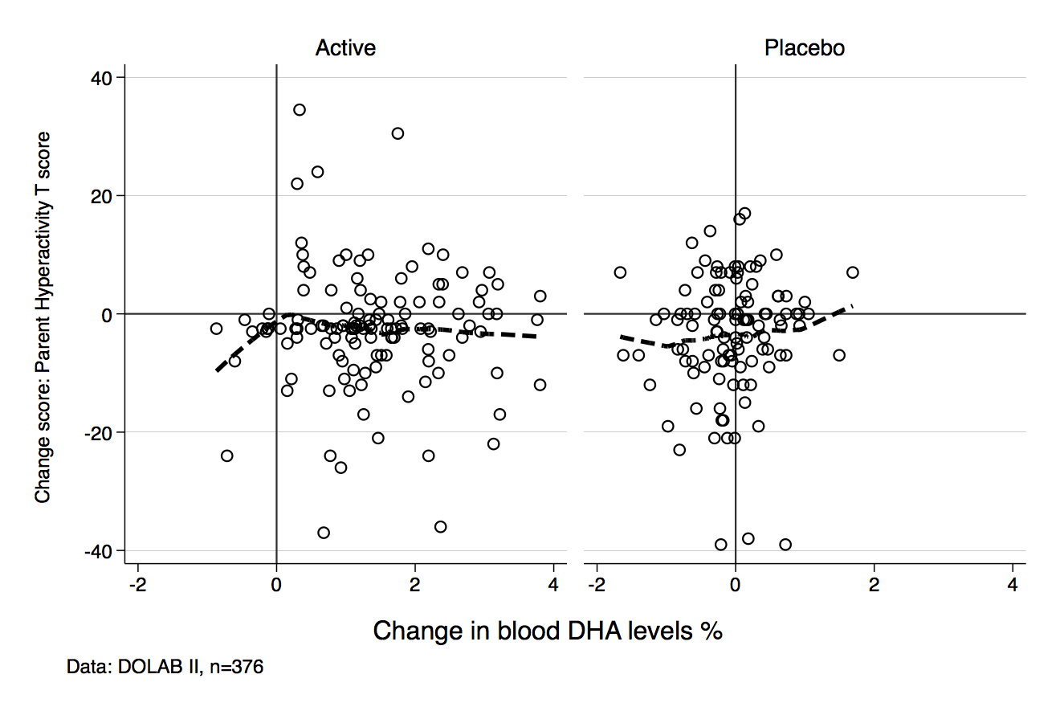

Change score: Parent Anxious-Shy T score
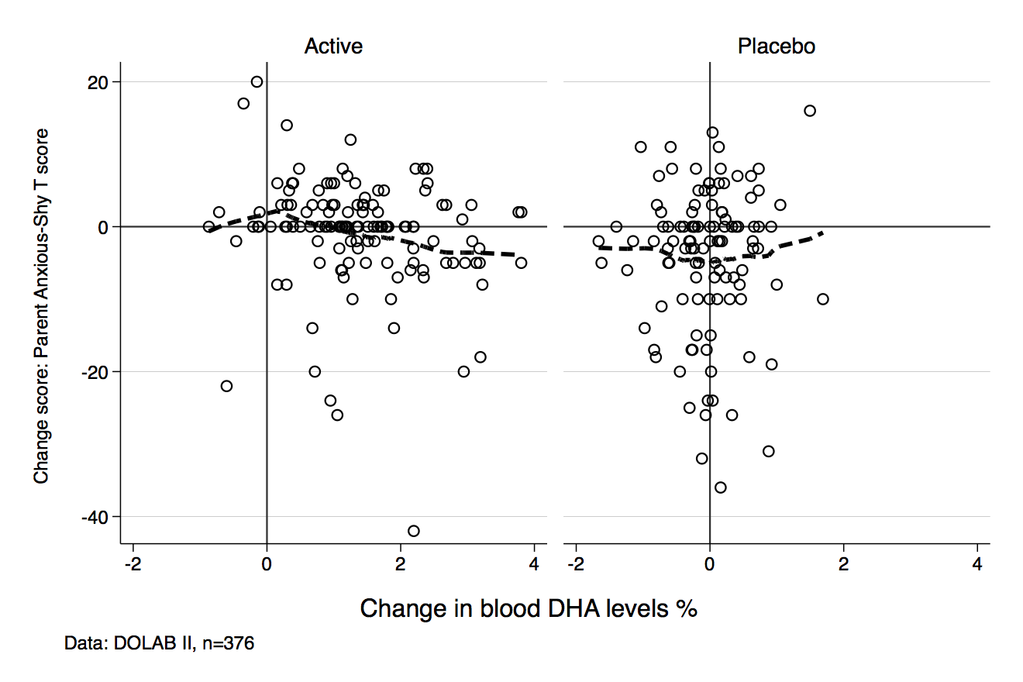

Change score: Parent Perfectionism T score
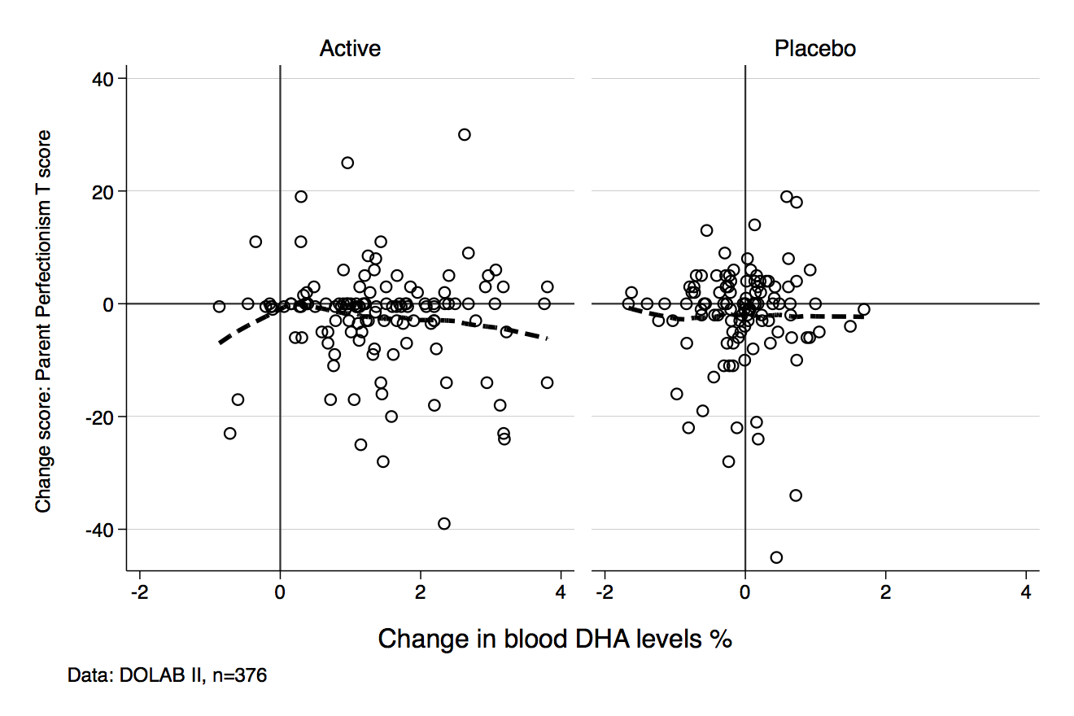

Change score: Parent Social Problems T score
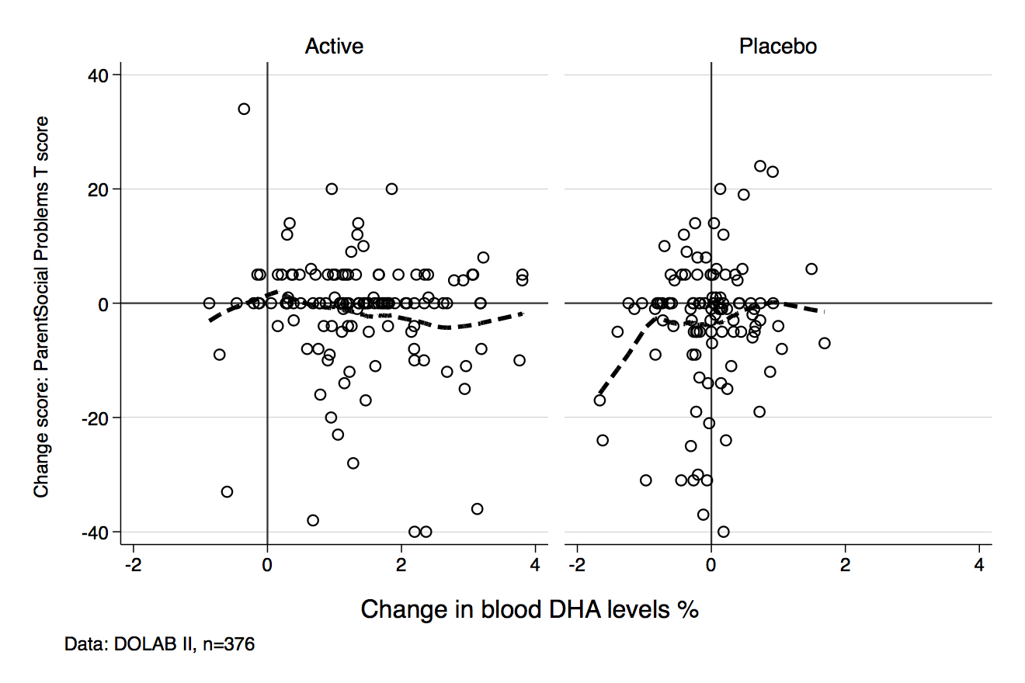

Change score: Parent Psychosomatic T score
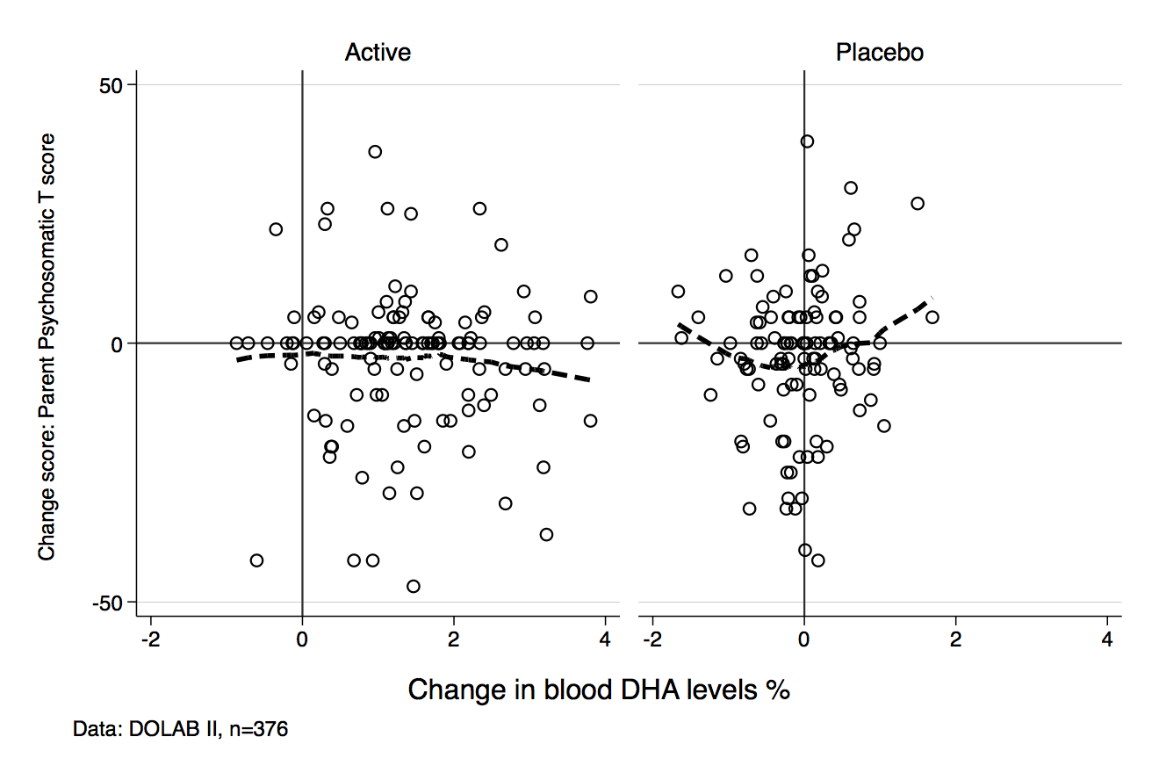

Change score: Parent ADHD Index T score
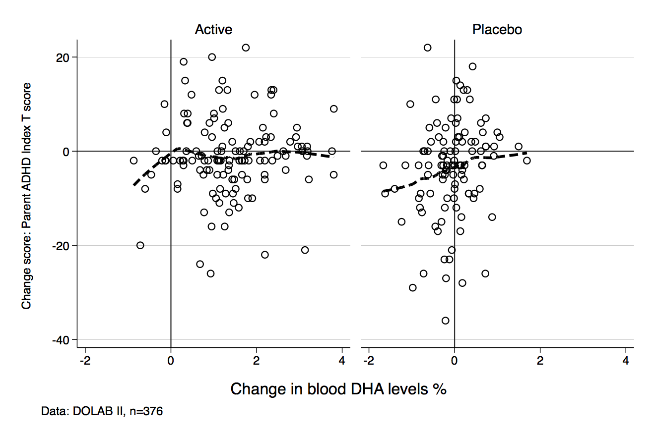

Change score: Parent Global Index Restless-Impulsive T score
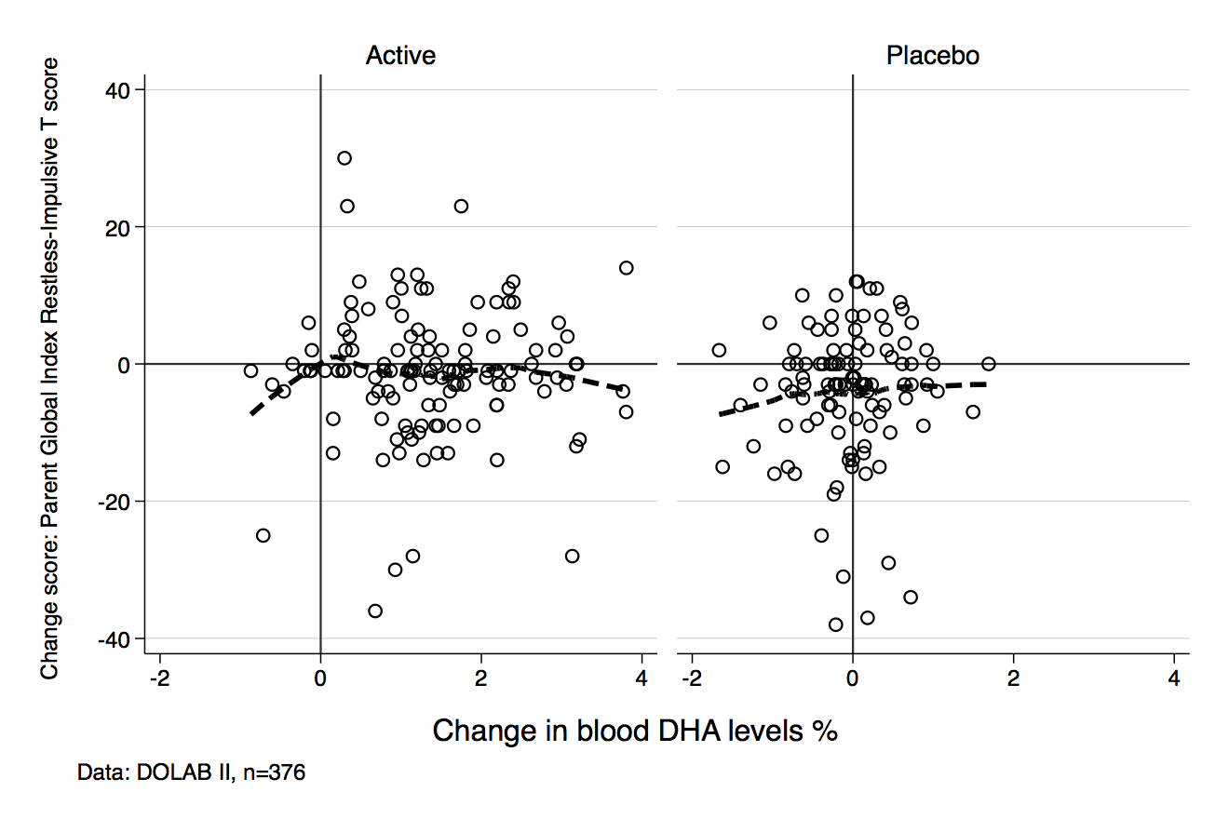

Change score: Parent Global Index Emotional Lability T score
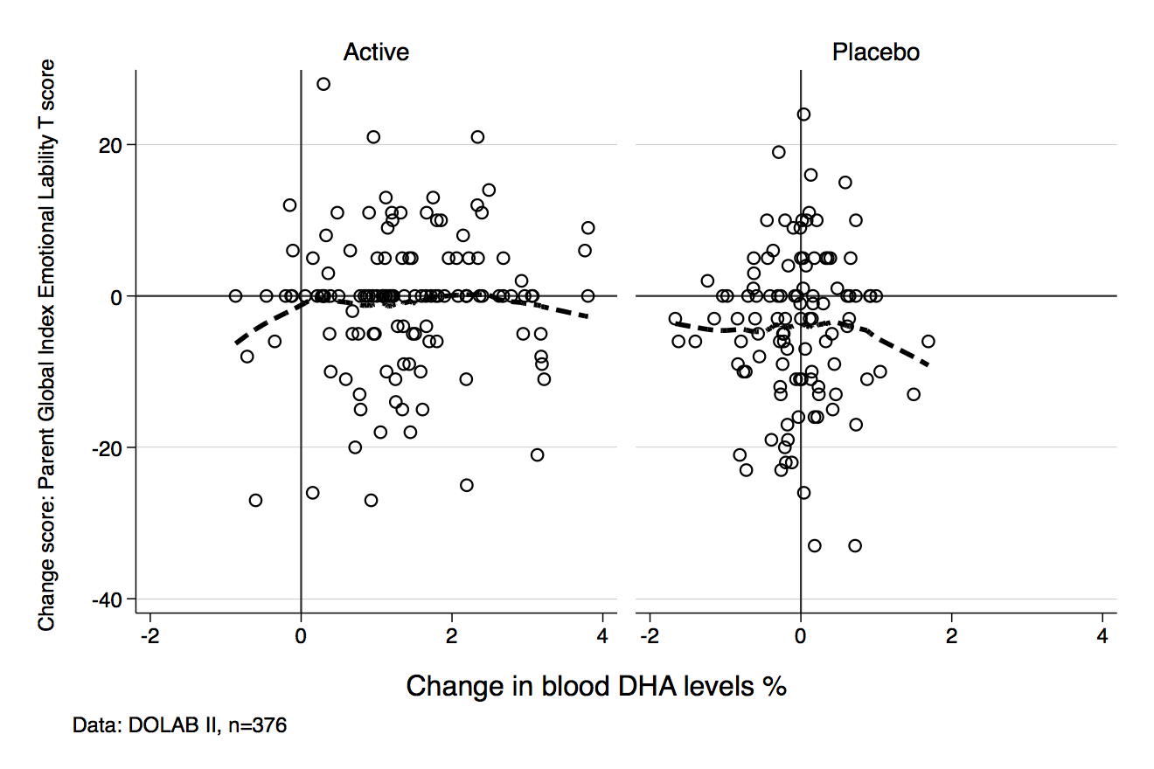

Change score: Parent Global Index Total T score
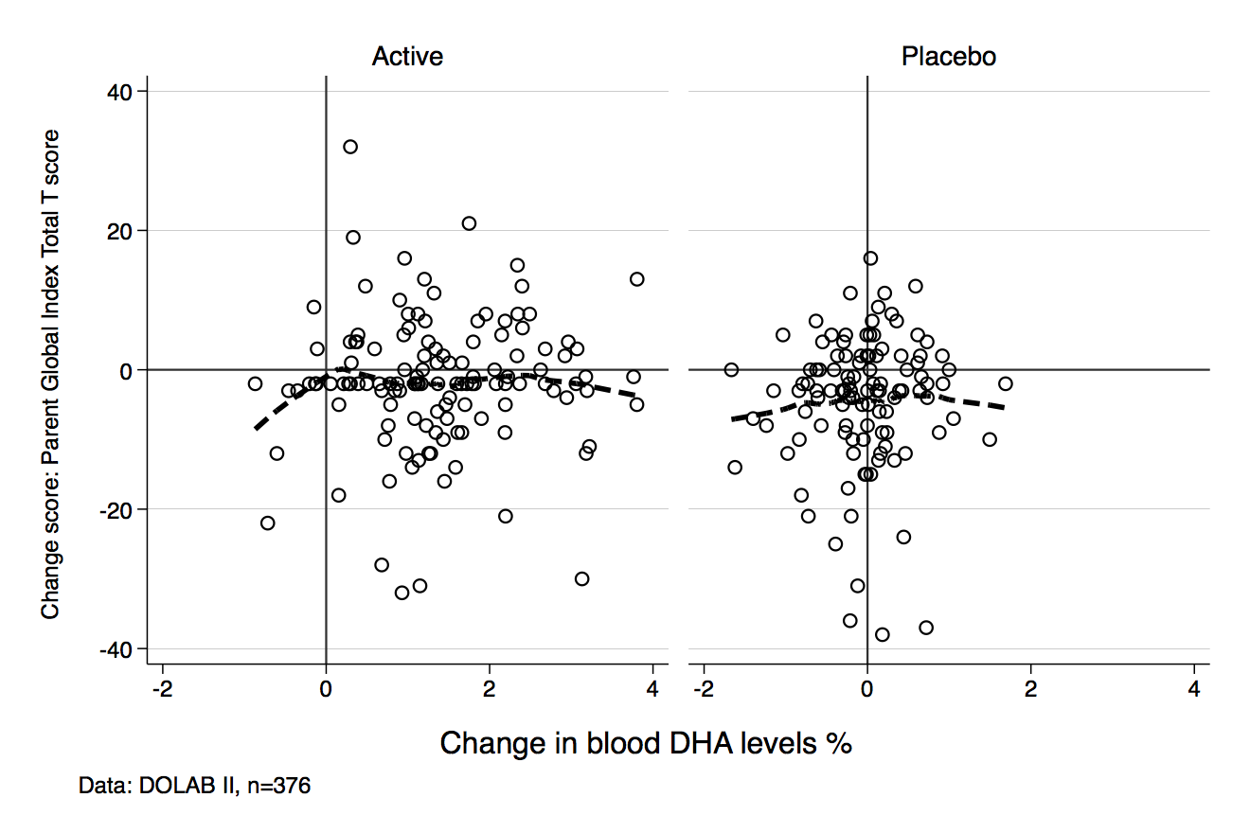

Change score: Parent DSM-IV Inattentive T score
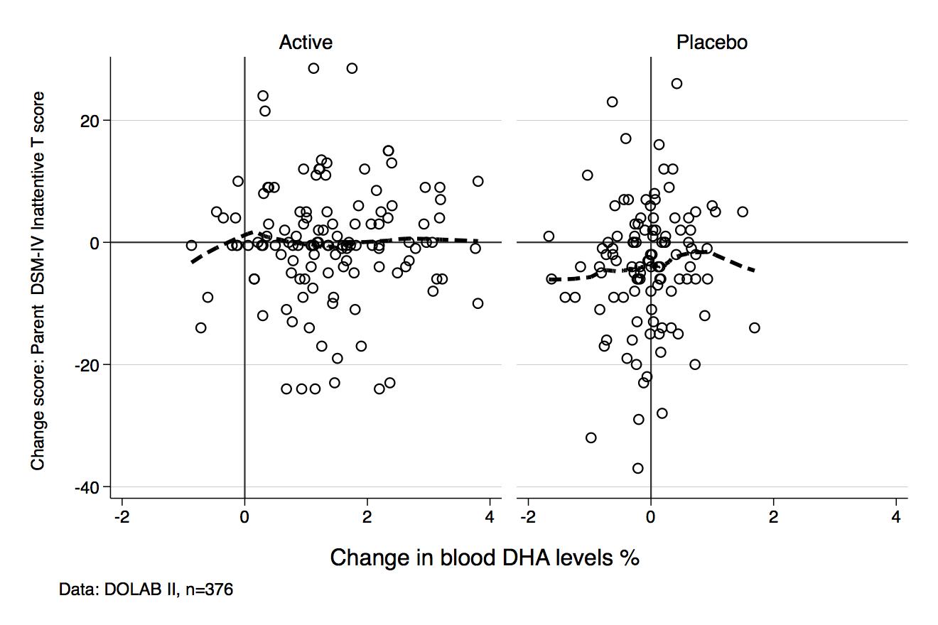

Change score: Parent DSM-IV Hyperactive-Impulsive T score
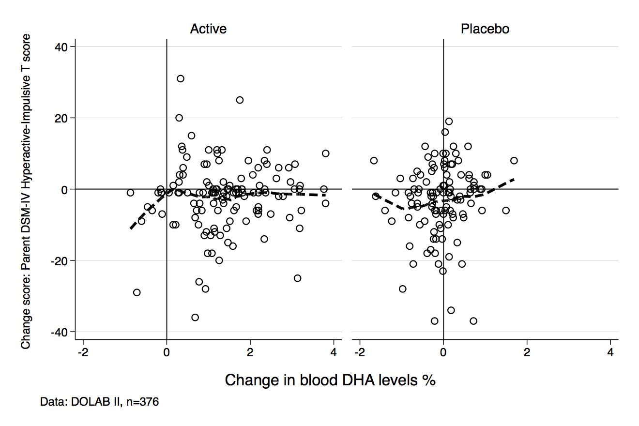

Change score: Baseline Parent DSM-IV Total T score
