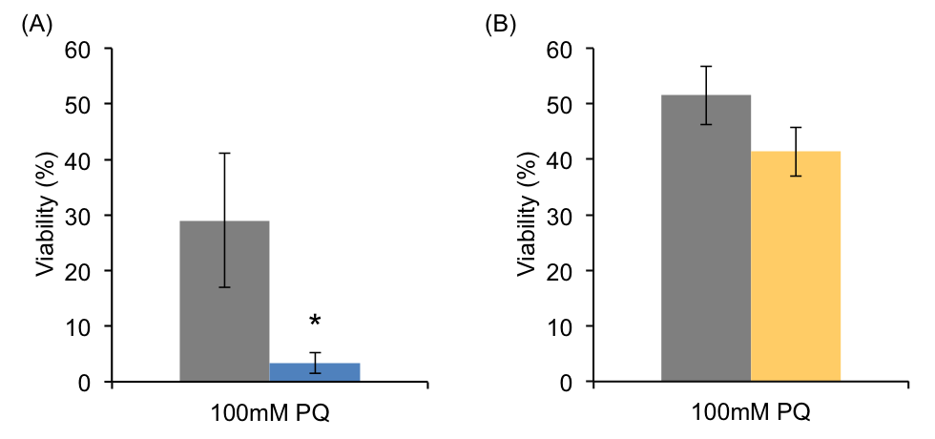

S5 Fig. Developmental RNAi of fard-1 Results in Significant Stress Sensitivity.
(A) There was significant variability in survival under PQ treatment; however, it is clear that developmental fard-1 RNAi resulted in significant reduction in survivorship when subjected to 100mM PQ in M9 buffer after 72 hours. This treatment was done in small scale to confirm the oxidative stress phenotype of fard-1 loss-of-function animals (Shi et al, 2016). (B) Adult-only fard-1 RNAi resulted in a reduced survivorship in 100mM PQ, but this change was not statistically significant (p=0.15). These animals were counted at 48 hours and performed in large-scale in order to process the same animals for lipid analysis. Data shown are from 5 biological replicates for developmental RNAi and from 12 replicates for adult-only RNAi. SEM is shown, and *p<0.05 was determined by unpaired t-tests.

