Eliminating yellow fever epidemics in Africa: vaccine demand forecast and impact modelling
Short title : Modelling the Elimination of Yellow Fever epidemics in Africa

S5 Figure

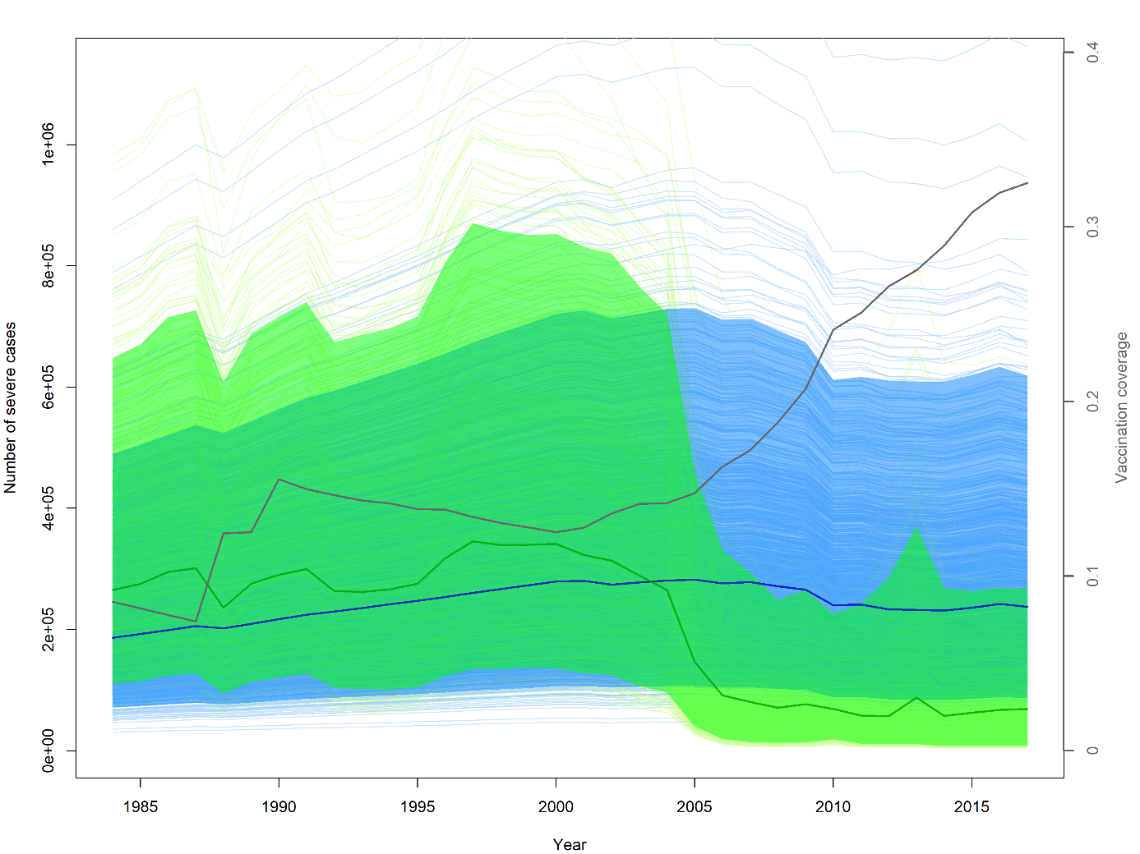
S5 Figure: Comparison of yellow fever burden estimates over time between both model versions across the whole endemic region (34 countries). Light blue lines: individual FOI model runs, 1,000 simulations. Dark blue line: median FOI model burden. Blue region: 95% Credible Interval of the FOI model burden. Light green lines: individual R0 model runs, 1,000 simulations. Dark green line: median R0 model burden. Green region: 95% Credible Interval of the FOI model burden. Grey line: overall population-level vaccination coverage across the whole endemic region.

