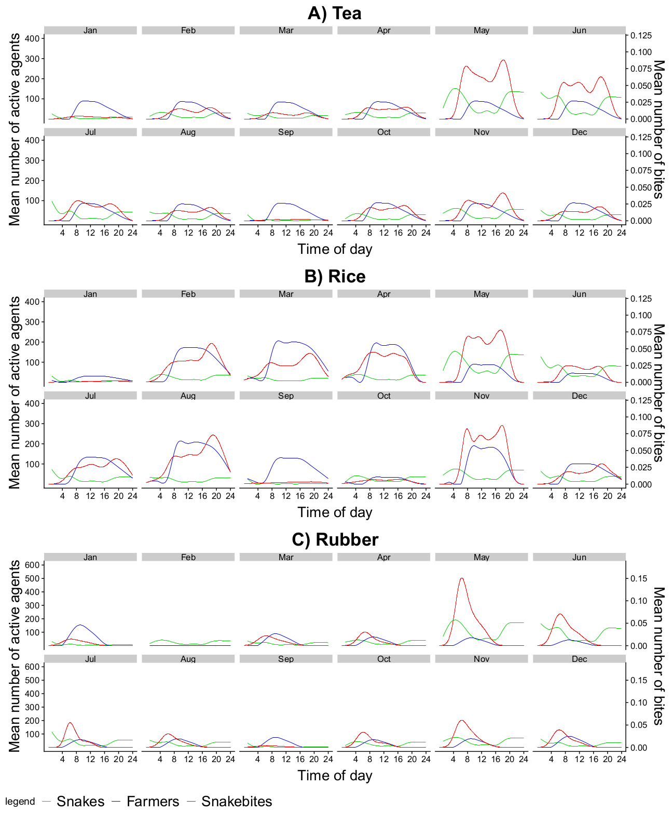
The daily spatial temporal overlap of farmers and snakes. The values are an average of 660 simulation runs. Each graph follows the daily spatio-temporal overlap between farmers and snakes that cause the emergence of snakebites patterns for A) tea B) rice, and C) rubber.

