Figure A. DMSO tolerance

Figure B. Effect of infection on replication

Table A. Identities and Potencies for the hits from the bio-actives screen.

|  |  |  |  |  |
| --- | --- | --- | --- | --- |
| **Structure** | **ID** | **Name** | **pEC50 (cruzi)** | **pEC50 (Vero)** |
| |  | | --- | | C26H28Cl2N4O4 | | DDD00089152 | Ketoconazole | 8.3 | 4.5 |
| |  | | --- | | C22H17ClN2 | | DDD00072003 | Clotrimazole | 8.2 | 4.9 |
| |  | | --- | | C22H18N2 | | DDD00203474 | Bifonazole | 8.0 | 4.8 |
| |  | | --- | | C35H38Cl2N8O4 | | DDD00771212 | Itraconazole | 8.0 | 4.8 |
| |  | | --- | | C18H15Cl3N2O | | DDD00071963 | Econazole | 7.7 | 5.0 |
| |  | | --- | | C16H14F3N5O | | DDD00203439 | Voriconazole | 7.6 | 4.3 |
| |  | | --- | | C18H14Cl4N2O | | DDD00072350 | Miconazole | 7.5 | 5.1 |
| |  | | --- | | C21H26ClNO | | DDD00089423 | Clemastine | 7.0 | 4.6 |
| |  | | --- | | C22H24ClN3O | | DDD00771290 | Azelastine | 6.6 | 4.8 |
| |  | | --- | | C20H25ClN2O5 | | DDD00089534 | Amlodipine | 6.3 | 5.1 |
| |  | | --- | | C21H27NO2 | | DDD00071948 | Ifenprodil | 6.3 | 4.3 |
| |  | | --- | | C26H33NO2 | | DDD00771727 | Abiraterone | 6.1 | 4.5 |
| |  | | --- | | C6H6N4O4- | | DDD00071930 | Nitrofurazone | 6.0 | 4.8 |
| |  | | --- | | C27H28N2O7- | | DDD00089508 | Cilnidipine | 5.9 | 4.8 |
| |  | | --- | | C21H27NO | | DDD00203415 | Benproperine | 5.9 | 4.8 |
| |  | | --- | | C21H21ClN4OS | | DDD00771620 | Ziprasidone | 5.8 | 4.6 |
| |  | | --- | | C21H26N2O7- | | DDD00203537 | Nimodipine | 5.7 | 4.8 |
| |  | | --- | | C28H31N3O6- | | DDD00203446 | Benidipine | 5.7 | 5.0 |
| |  | | --- | | C18H18O2 | | DDD00718048 | Honokiol | 5.7 | 5.1 |
| |  | | --- | | C26H37NO2 | | DDD00089160 | N-arachidonoylaminophenol | 5.7 | 4.8 |
| |  | | --- | | C28H30N6OS | | DDD00771571 | Masitinib | 5.7 | 5.1 |
| |  | | --- | | C10H13N5O3 | | DDD00237073 | 3'-deoxydenosine | 5.6 | 4.3 |
| |  | | --- | | C28H22F3N7O | | DDD00771565 | Nilotinib | 5.6 | 4.8 |
| |  | | --- | | C12H9NS | | DDD00728190 | Phenothiazine | 5.6 | 4.8 |
| |  | | --- | | C20H24ClN3S | | DDD00066604 | Prochlorperazine | 5.6 | 5.2 |
| |  | | --- | | C23H27Cl2N3O2 | | DDD00771276 | Aripiprazole | 5.6 | 4.9 |
| |  | | --- | | C21H26N2S2 | | DDD00072344 | Thioridazine | 5.6 | 5.2 |
| |  | | --- | | C30H32N2O2 | | DDD00203482 | Diphenoxylate | 5.6 | 4.8 |
| |  | | --- | | C18H23NO | | DDD00089258 | Bifemelane | 5.5 | 4.8 |
| |  | | --- | | C22H26F3N3OS | | DDD00071956 | Fluphenazine | 5.5 | 5.0 |
| |  | | --- | | C18H18ClNS | | DDD00771663 | Chlorprothixene | 5.5 | 4.8 |
| |  | | --- | | C17H17F3N4 | | DDD00771283 | CGS 12066B | 5.5 | 4.8 |
| |  | | --- | | C27H30F2N2O3 | | DDD00203486 | Lomerizine | 5.4 | 4.8 |
| |  | | --- | | C26H29N3O6- | | DDD00771347 | Cardene | 5.4 | 4.8 |
| |  | | --- | | C18H20N2O6- | | DDD00203472 | Nitrendipine | 5.4 | 4.8 |
| |  | | --- | | C33H40N2O9 | | DDD00089475 | Reserpine | 5.4 | 4.3 |
| |  | | --- | | C22H27NO2 | | DDD00771174 | Danazol | 5.4 | 4.8 |
| |  | | --- | | C12H15N5O3 | | DDD00771732 | Entecavir | 5.4 | 4.8 |
| |  | | --- | | C17H19ClN2S | | DDD00066605 | Chlorpromazine | 5.4 | 5.0 |
| |  | | --- | | C29H33ClN2O2 | | DDD00072189 | Loperamide | 5.4 | 4.7 |
| |  | | --- | | C32H47F5O3S | | DDD00771578 | Fulvestrant | 5.3 | 4.8 |
| C19H20FNO3 | DDD00072581 | Paroxetine | 5.3 | 4.9 |
| |  | | --- | | C21H23NO | | DDD00771673 | Dapoxetine | 5.3 | 4.8 |
| |  | | --- | | C14H16N2O2 | | DDD00089418 | Etomidate | 5.3 | 4.3 |
| |  | | --- | | C22H27N3O2S2 | | DDD00203735 | Thiothixene | 5.3 | 5.1 |
| |  | | --- | | C25H27ClN2 | | DDD00071813 | Meclizine | 5.3 | 4.7 |
| |  | | --- | | C23H25N5O5 | | DDD00072588 | Doxazosin | 5.3 | 4.8 |
| |  | | --- | | C24H26N2O4 | | DDD00089482 | Carvedilol | 5.3 | 4.8 |
| |  | | --- | | C18H19Cl2NO4 | | DDD00203741 | Felodipine | 5.3 | 4.8 |
| |  | | --- | | C29H31N7O | | DDD00771286 | Imatinib | 5.3 | 4.8 |
| |  | | --- | | C21H27N3 | | DDD00089407 | Rimcazole | 5.3 | 5.0 |
| |  | | --- | | C20H23N | | DDD00071714 | Maprotilline | 5.3 | 4.8 |
| |  | | --- | | C21H32N2O | | DDD00771210 | Stanozolol | 5.3 | 4.8 |
| |  | | --- | | C16H15Cl2N | | DDD00089028 | Indatraline | 5.3 | 4.9 |
| |  | | --- | | C19H21N5O4 | | DDD00072649 | Prazosin | 5.3 | 5.0 |
| |  | | --- | | C12H15ClO3 | | DDD00089746 | Clofibrate | 5.2 | 4.8 |
| |  | | --- | | C26H26N2O3 | | DDD00089440 | SDM25N | 5.2 | 4.8 |
| |  | | --- | | C33H34N6O6 | | DDD00771693 | Candesartan cilexetil | 5.2 | 4.9 |
| |  | | --- | | C17H18F3NO | | DDD00071907 | Fluoxetine | 5.2 | 4.7 |
| |  | | --- | | C23H30N4O2S | | DDD00771265 | Perospirone | 5.2 | 4.8 |
| |  | | --- | | C19H23ClN2 | | DDD00065535 | Clomipramine | 5.2 | 4.8 |
| |  | | --- | | C20H32N5O8P | | DDD00771651 | Adefovir Dipivoxil | 5.2 | 4.8 |
| |  | | --- | | C19H19ClN2 | | DDD00300268 | Desloratadine | 5.2 | 4.8 |
| |  | | --- | | C18H19NOS | | DDD00203552 | Duloxetine | 5.2 | 4.8 |
| |  | | --- | | C12H7Cl3O2 | | DDD00771322 | Triclosan | 5.1 | 5.0 |
| |  | | --- | | C21H35NO | | DDD00771642 | Amorolfine | 5.0 | 4.8 |
| |  | | --- | | C47H64N4O12 | | DDD00203506 | Rifapentine | 5.0 | 4.8 |
| |  | | --- | | C23H32O3 | | DDD00771182 | 17β-estradiol 17-valerate | 5.0 | 4.9 |
| |  | | --- | | C27H30F6N2O2 | | DDD00771580 | Dutasteride | 4.8 | 4.8 |

**Figure C *T.cruzi* and H1-binding for a panel of Azelastine analogues**

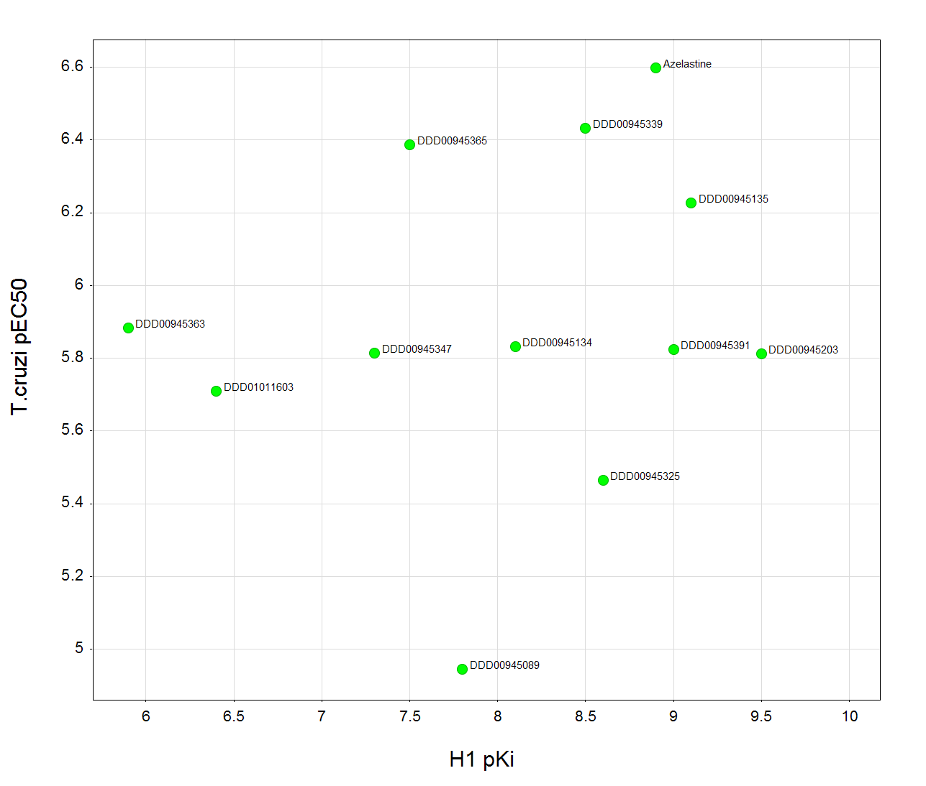

**Table B Azelastine analogues**

|  |  |
| --- | --- |
| **Structure** | **DDD Code** |
| |  | | --- | | C22H24ClN3O | | Azelastine |
| |  | | --- | | C54H69Cl2N9O2 | | DDD00945089 |
| |  | | --- | | C29H35ClF3N5O4 | | DDD00945134 |
| |  | | --- | | C24H26ClF3N4O4 | | DDD00945135 |
| |  | | --- | | C22H25ClN4O2 | | DDD00945203 |
| |  | | --- | | C27H31ClF3N5O4 | | DDD00945325 |
| |  | | --- | | C26H29ClF3N5O4 | | DDD00945339 |
| |  | | --- | | C26H33Cl2N5O3 | | DDD00945347 |
| |  | | --- | | C28H36Cl2N4O2 | | DDD00945363 |
| |  | | --- | | C26H34Cl2N4O2 | | DDD00945365 |
| |  | | --- | | C28H34ClF3N4O6 | | DDD00945391 |
| |  | | --- | | C25H31N3O | | DDD01011603 |