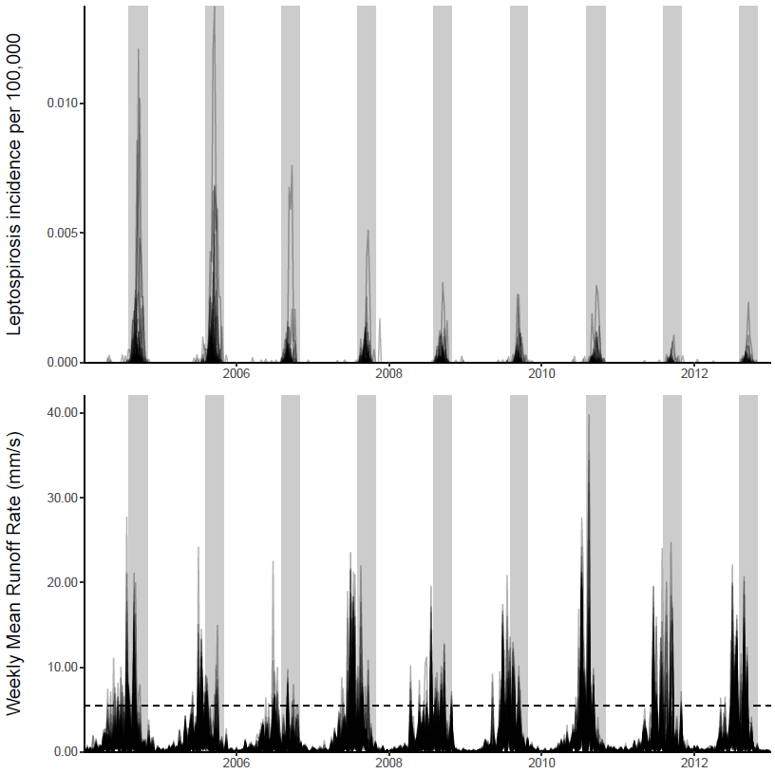
Upper panel shows weekly county-level leptospirosis incidence rates during the study period. Lower panel shows weekly mean runoff rates at the county-level. Shaded areas in both panels represent the transmission season considered during regression analyses, during which nearly all leptospirosis cases occur (August-October). Horizontal dashed line in lower panel represents the 97.5th percentile of all runoff values observed during the study period.

