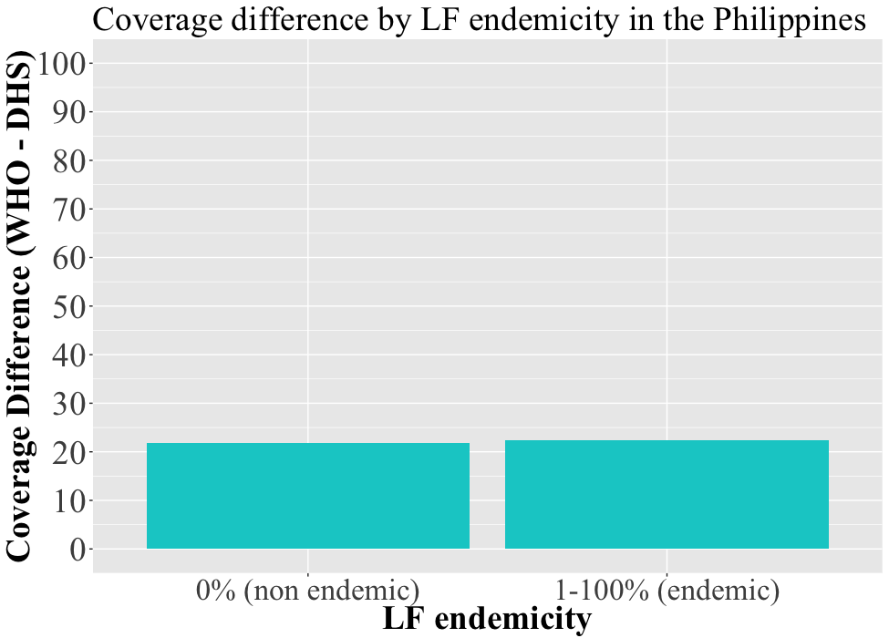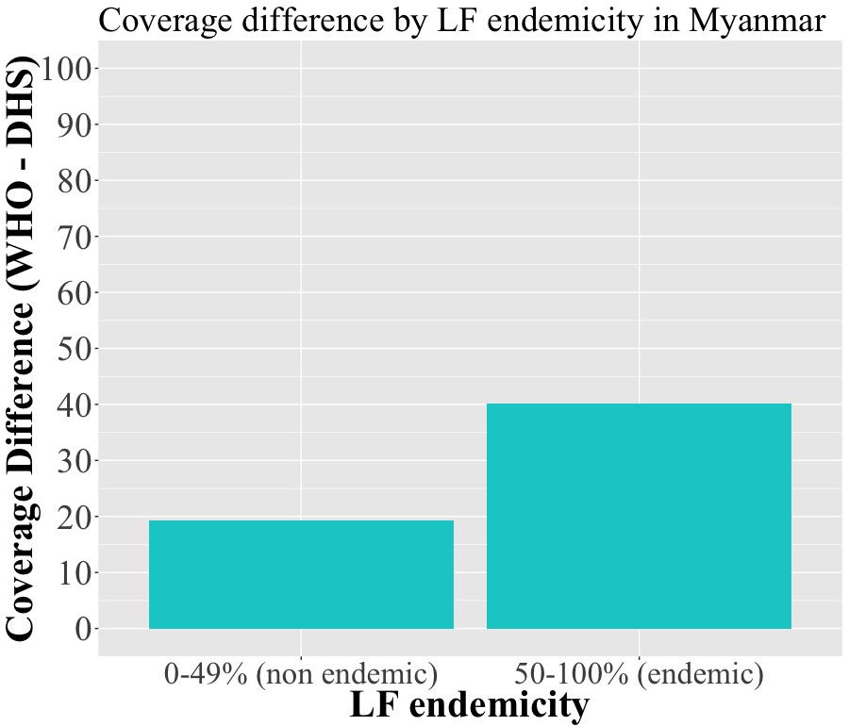
A
BD
Figure S7: Comparison of mean district-level deworming coverage in children 2-4 years of age reported to WHO and estimated by DHS for countries endemic to lymphatic filariasis stratified by level of endemicity. Endemicity to lymphatic filariasis was determined by sub-district-level data reported to WHO on the record of a treatment campaign during the year of deworming analysis within each country. In Myanmar, districts were categorized as endemic to lymphatic filariasis if half of sub-districts received treatment (panel A) and in the Philippines, districts were categorized as endemic to lymphatic filariasis if any of their sub-districts received treatment (panel B). Note difference in endemicity definition used for Myanmar and the Philippines.

