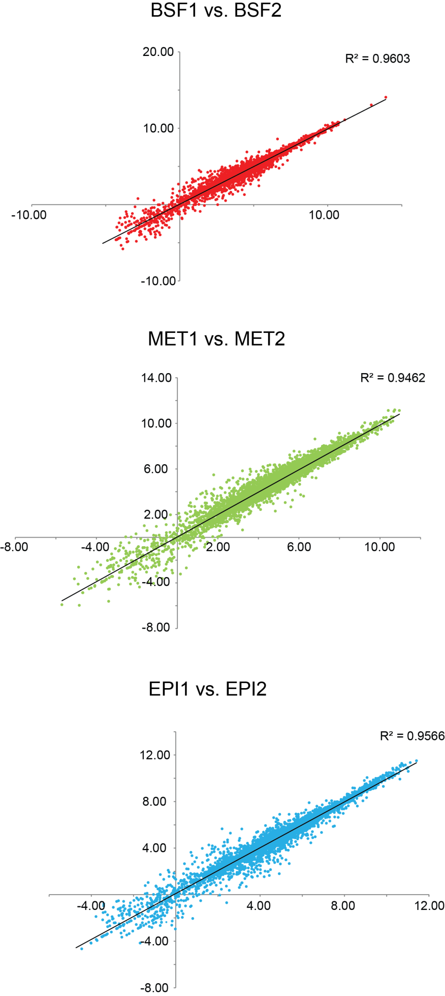
Supplementary Figure 1. Exemplar correlations of log-transformed transcript abundance (log2 FPKM), as estimated by Cufflinks, between replicate analyses of bloodstream form (BSF), metacyclic-stage (MET) and epimastigote (EPI) parasites.

