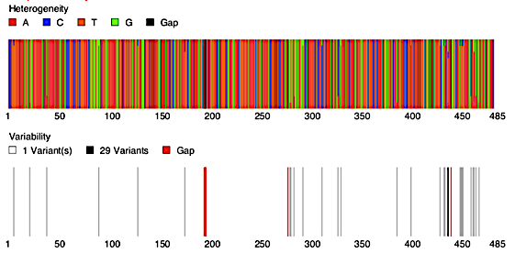
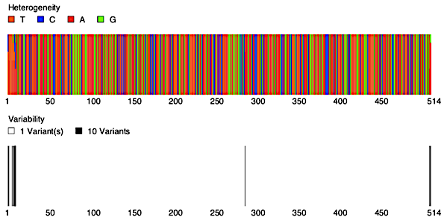
b)
a)

d)
c)

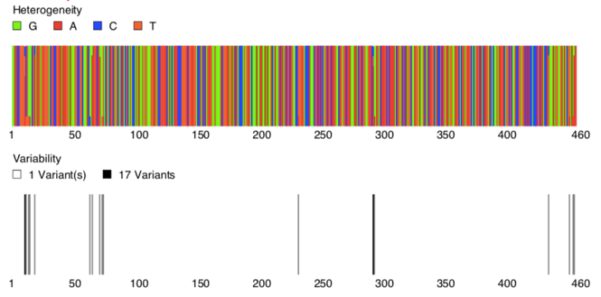
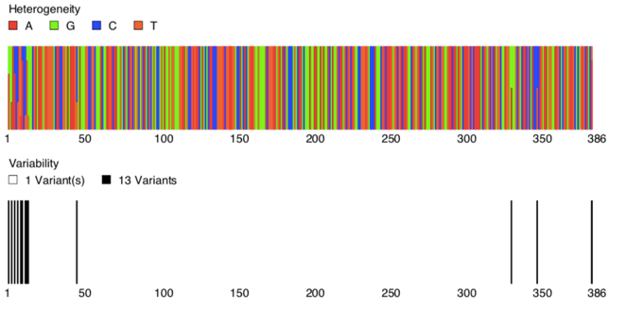
f)
e)

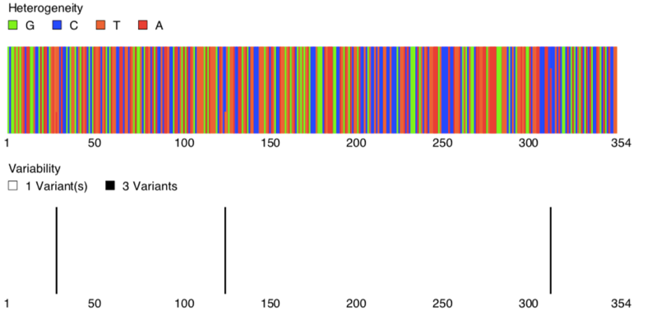
g)

S2 Fig. Heterogeneity and variability for an internal group of sequences that include endosymbiont’s from sand flies and mosquitoes. a) Group wCnig of Wolbachia (sequences of wsp gene) only with members from Cx. nigripalpus, b) Group wLeva of Wolbachia (sequences of wsp gene) only with members of Ev. dubitans and Mi. micropyga, c) Microsporidia from Culex, Lutzomyia pia and Microsporidian MB and other microsporidia of Clade IV (sequences of the SSU rRNA), d) Microsporidia only from Culex, Lutzomyia pia and Microsporidian MB, e) Cardinium endosymbiont’s (sequences of 16S rDNA) only with members of group C that include Sand flies and Culicoides host´s, f) Cardinium endosymbiont’s only with members of subgroup 1 from Mi. cayennensis, g) Cardinium endosymbiont’s only with members of subgroup 2 from Mi. cayennensis and Pi. evansi.

