Table S6. 32 individually validated hits
T. cruzi-active hits
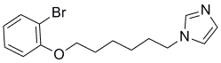 | 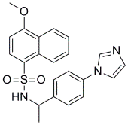 | 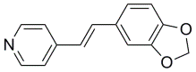 | 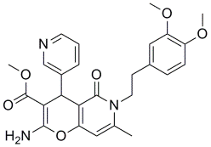
1ª (2)^{b} 0.017 μM^{c} | 3 (4) 0.20 μM | 5 (4) 0.26 μM | 6 (3) 0.08 μM
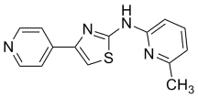 | 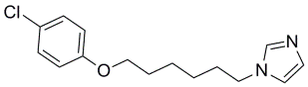 | 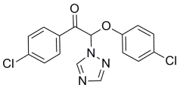 | 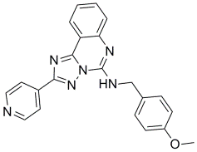
9 (4) 0.58 μM | 11 (5) 0.76 μM | 13 (5) 1.30 μM | 15 (5) 1.93 μM
CYP51 binding hits
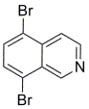 | 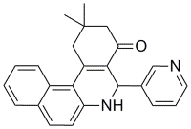 | 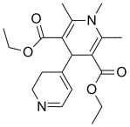 | 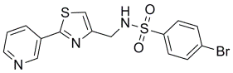
(4) | (5) | (5) | (5)
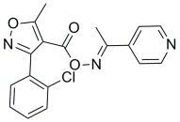 | 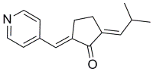 | 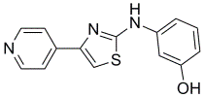 | 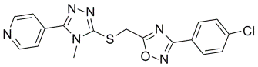
(5) | (4) | (4) | (5)
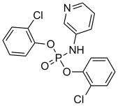 | 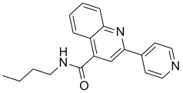 | 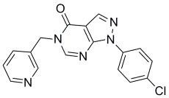 | 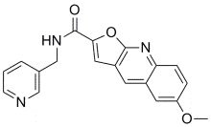
(5) | (5) | (5) | (5) low solubility
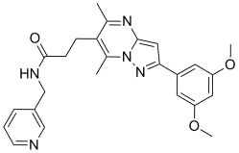 | 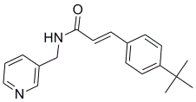 | 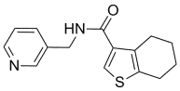 | 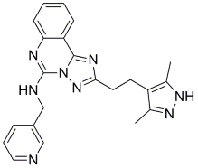
(5) | (5) | (5) | (5)
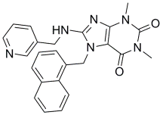 | 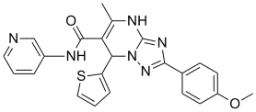 | 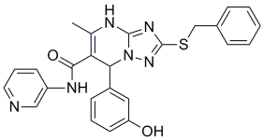 | 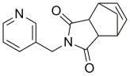
(4) | (4) | (4) | (5) low solubility
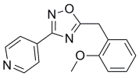 | 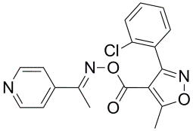 | 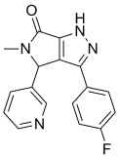 | 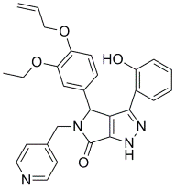
(4) | (5) | (5) | (5)
ª Rank in T. cruzi assay; ^{b}HTS binding score is given in parentheses; ^{c}EC₅₀ versus T. cruzi parasites are in μM.

