Gel concentration: 1.5%
Voltage: 120 V
Time: 50 min
DNA V loaded per sample: 4 uL
Dye V loaded per sample: 2 uL

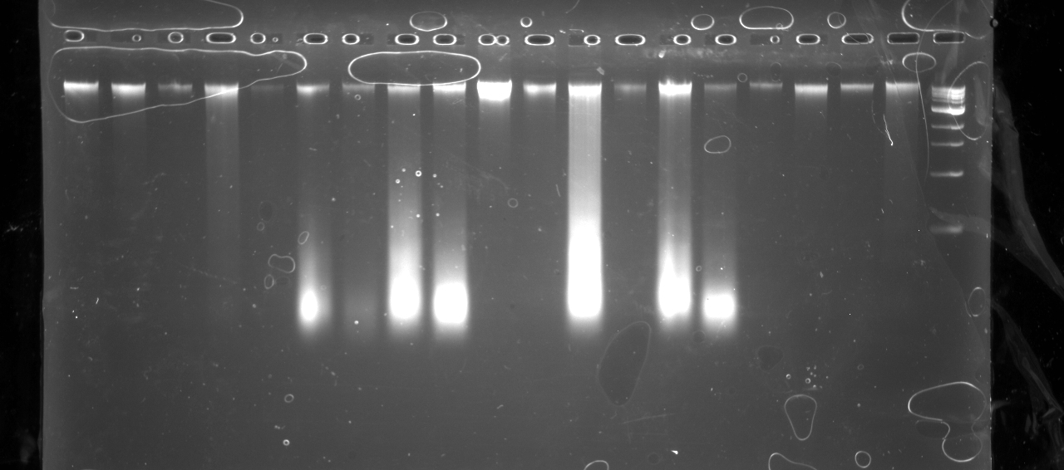

Fig. S1 representative agarose gel separation of extractions from abdomen of T. dimidiata. The upper band, indicated by the black arrow, is intact genomic DNA. In lanes 6-9, 12, and 13-14, a second band of degraded DNA (1-200bp), indicated by the red arrow, is likely partially-digested blood meal. 1kb ladder is loaded in the far-right lane for comparison.

