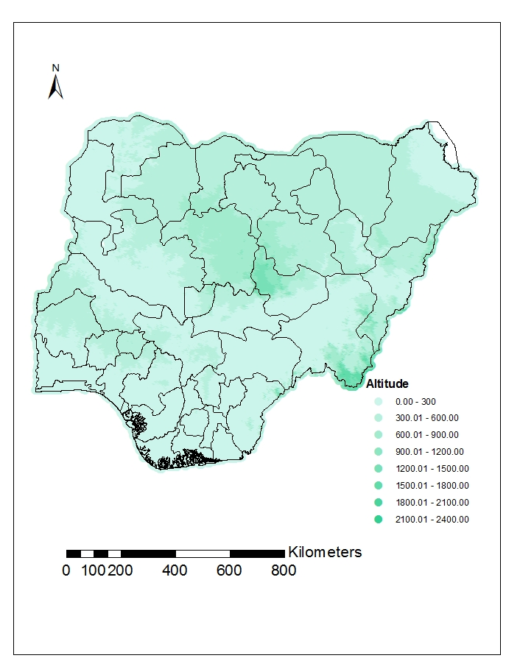
S2A Fig: Map of altitude

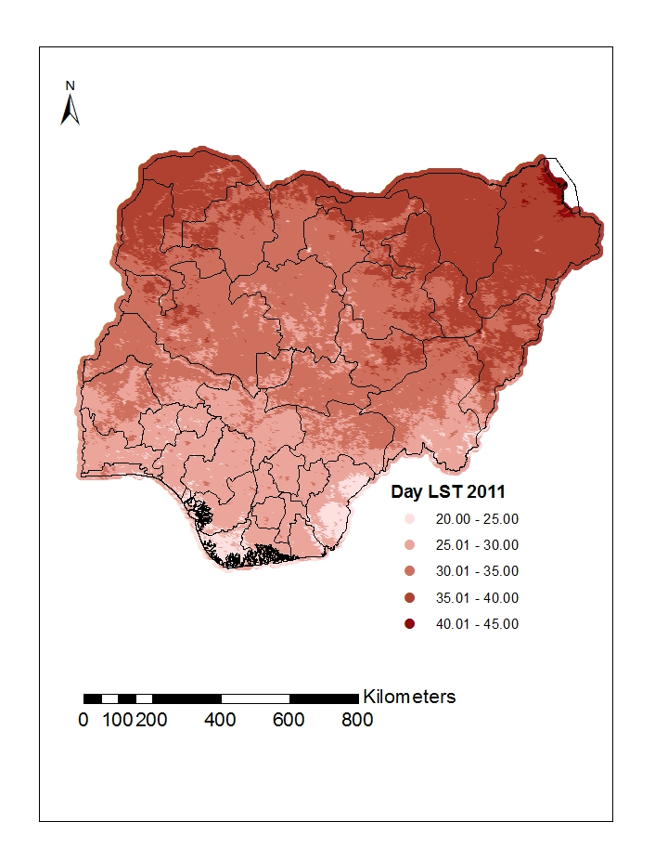
S2B Fig: Map of day Land surface temperature in 2011

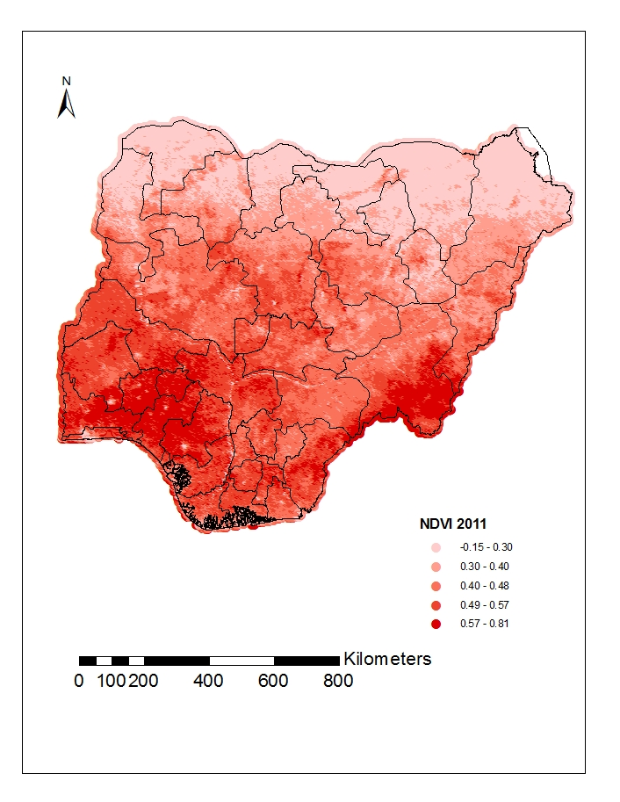
S2C Fig: Map of Normalize Differential Vegetation Index in 2011
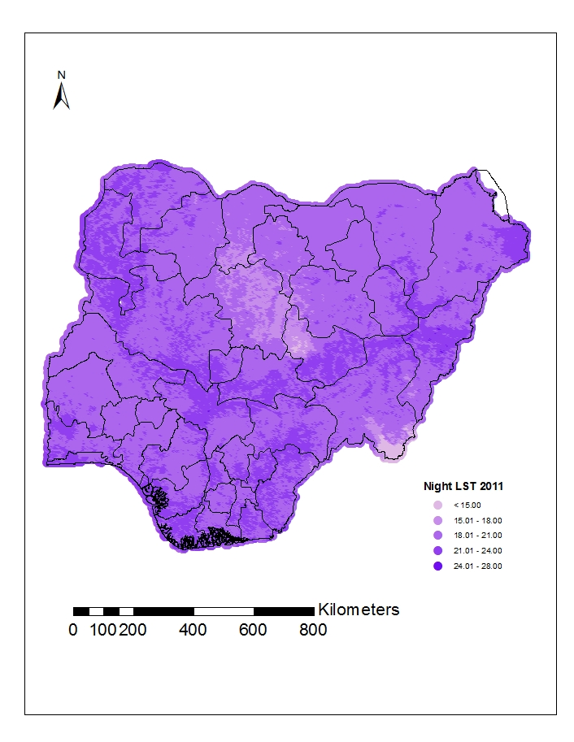
S2D Fig: Map of Night Land Surface Temperature in 2011

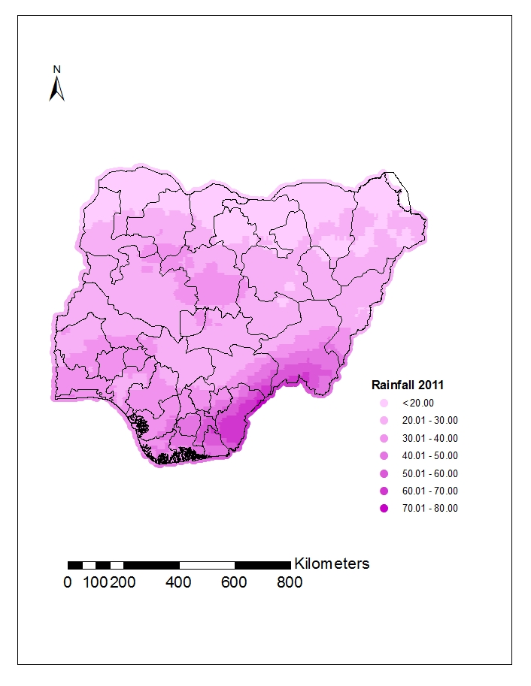
S2E Fig: Map of Rainfall in 2011

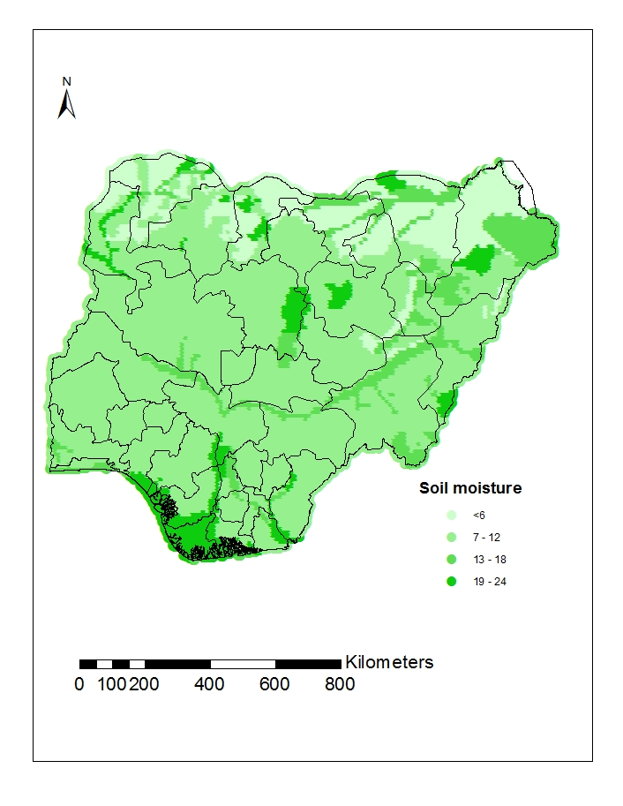
S2F Fig: Map of Soil moisture in 2011

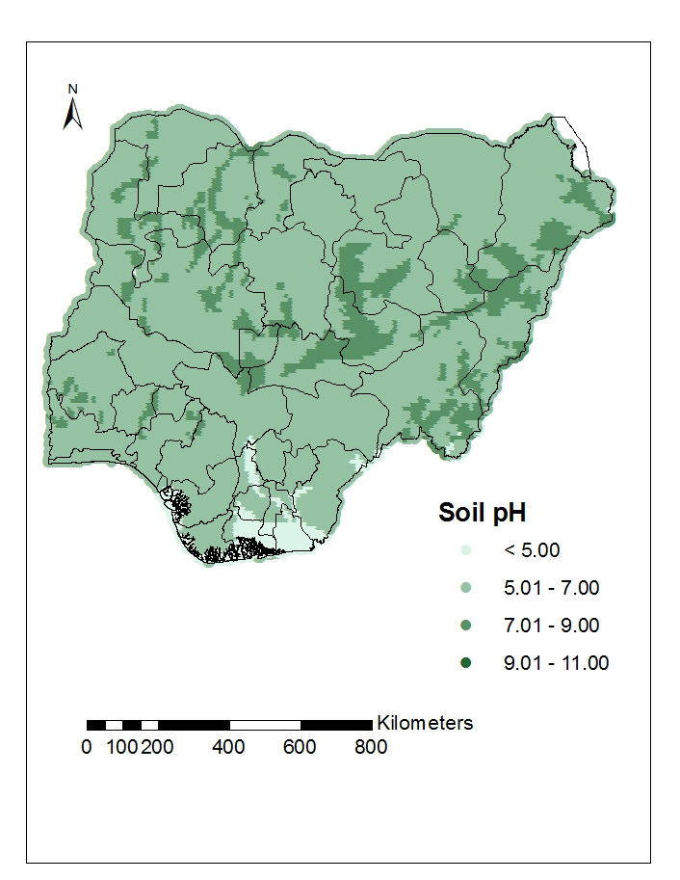
S2G Fig: Map of Soil pH in 2011

