A Novel Immunotherapy of Brucellosis in Cows Monitored Non Invasively Through a Specific Biomarker
Hari Mohan Saxena and Sugandha Raj

Supplementary information

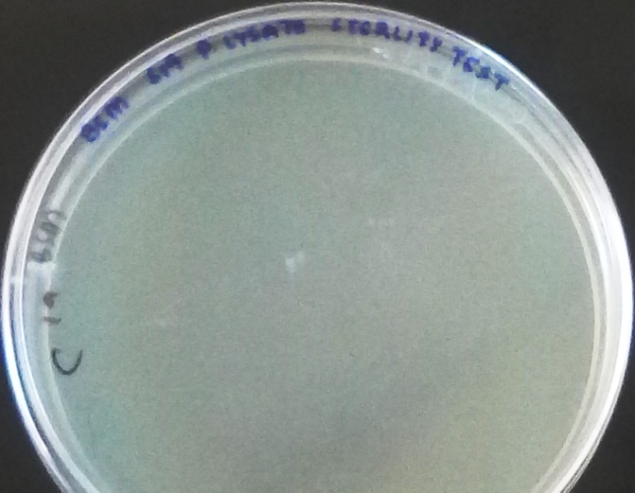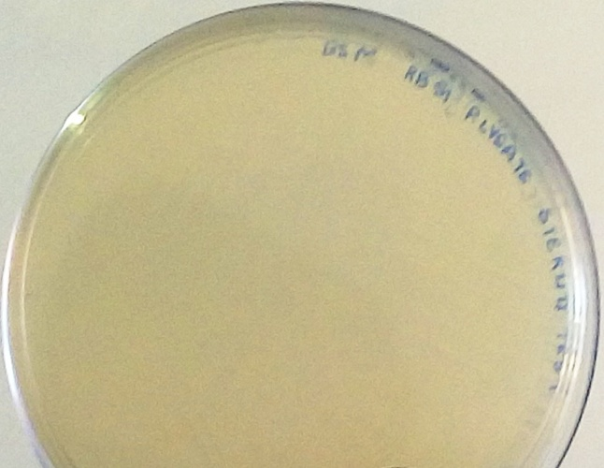
S3 Fig. Sterility test of lysates (left: S19 and right: RB51) showing no growth of organisms

