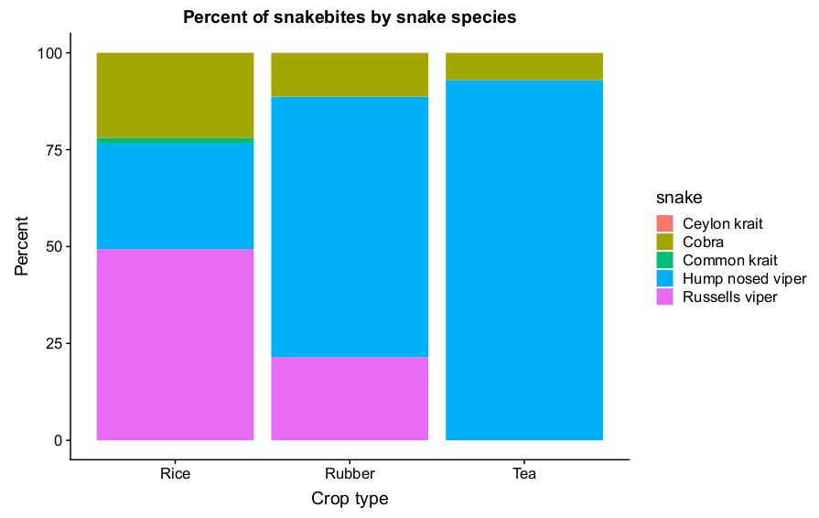
A secondary predictions of species biting on each landcover. Our model shows that the different landcovers are going to have different compositions of snake species causing snakebites.

