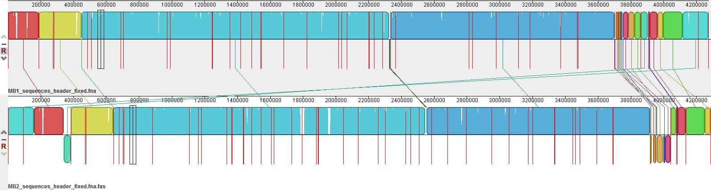
MB1 (upper) vs. MB2 (lower)

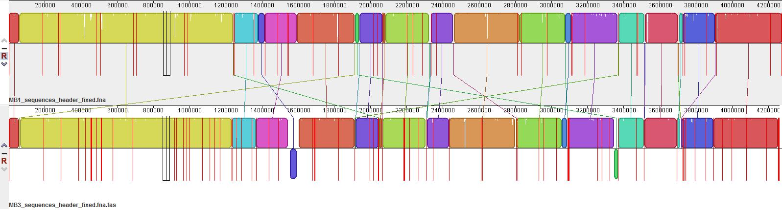
MB1 (upper) vs. MB3 (lower)

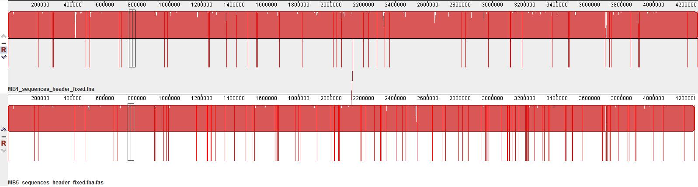
MB1 (upper) vs. MB4 (lower)

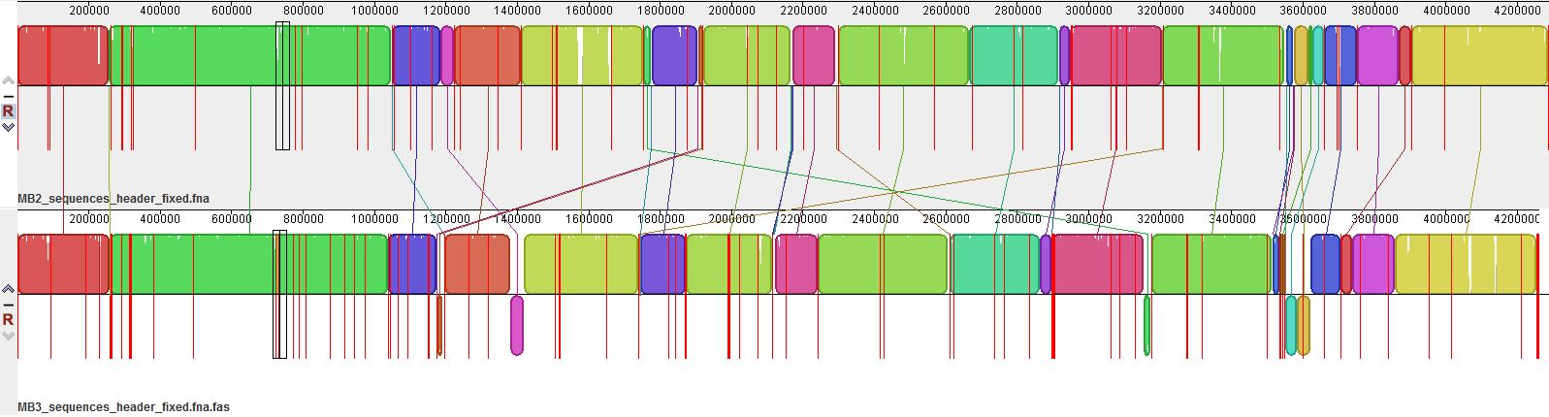
MB2 (upper) vs. MB3 (lower)

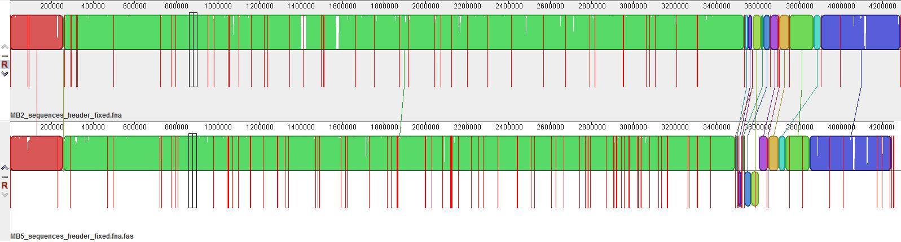
MB2 (upper) vs. MB4 (lower)

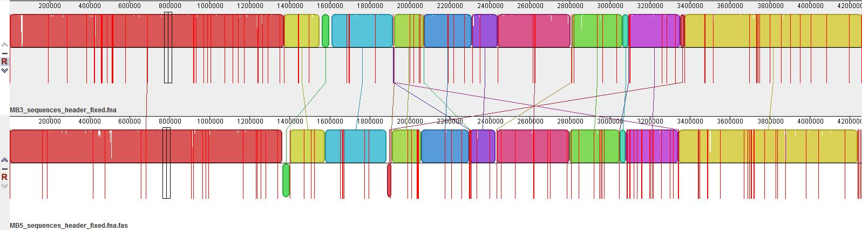
MB3 (upper) vs. MB4 (lower)

S2 Figure. Genome sequence comparison between mycobacteria isolates using Differences program.

