S2 Fig. Within-group and between-group distances. (A) Microbiome dataset (weighted UniFrac). (B) Metabolome dataset (Bray-Curtis-Faith). *, p<0.05 (Mann-Whitney, FDR-corrected).
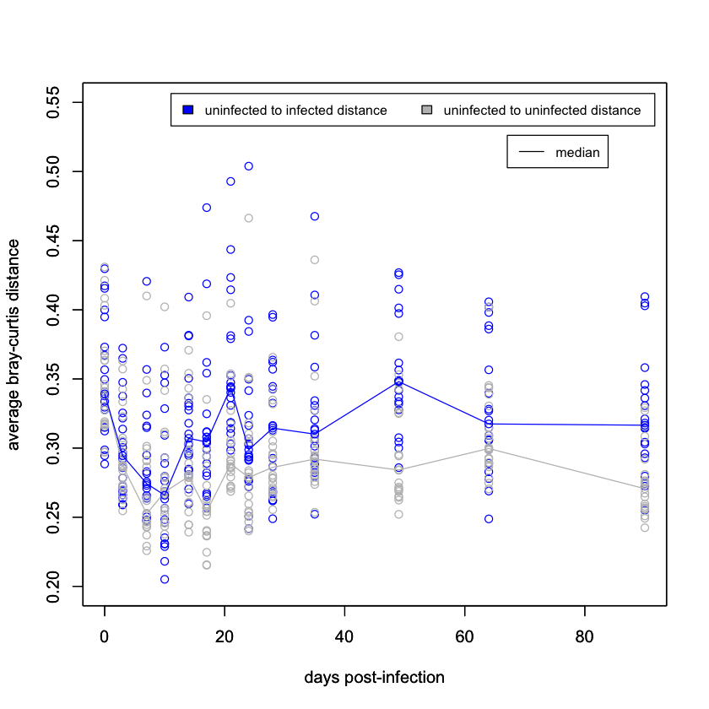
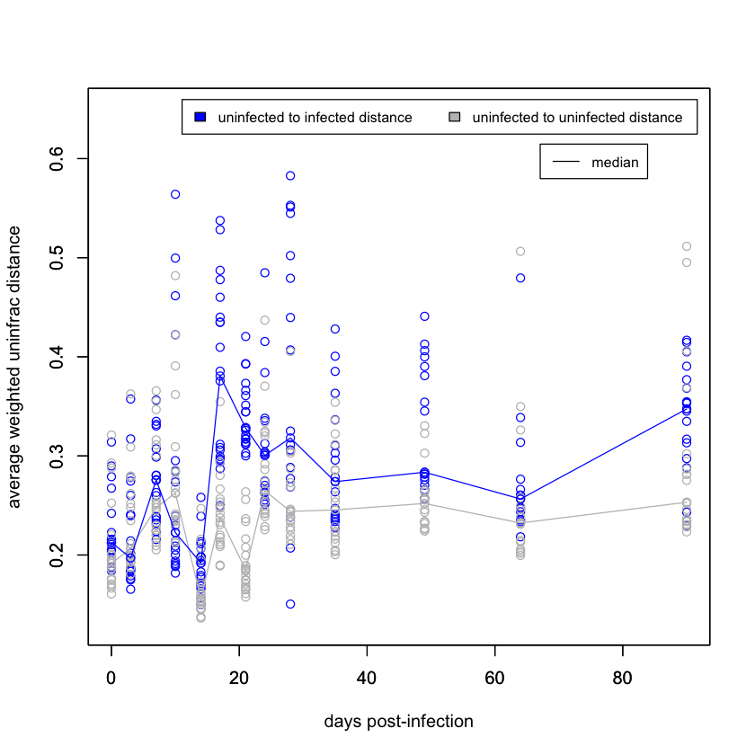
B
A
*
*
*
*
*
*
*
*
*
*
*

