**S2 TEXT: SUPPORTING FIGURES**

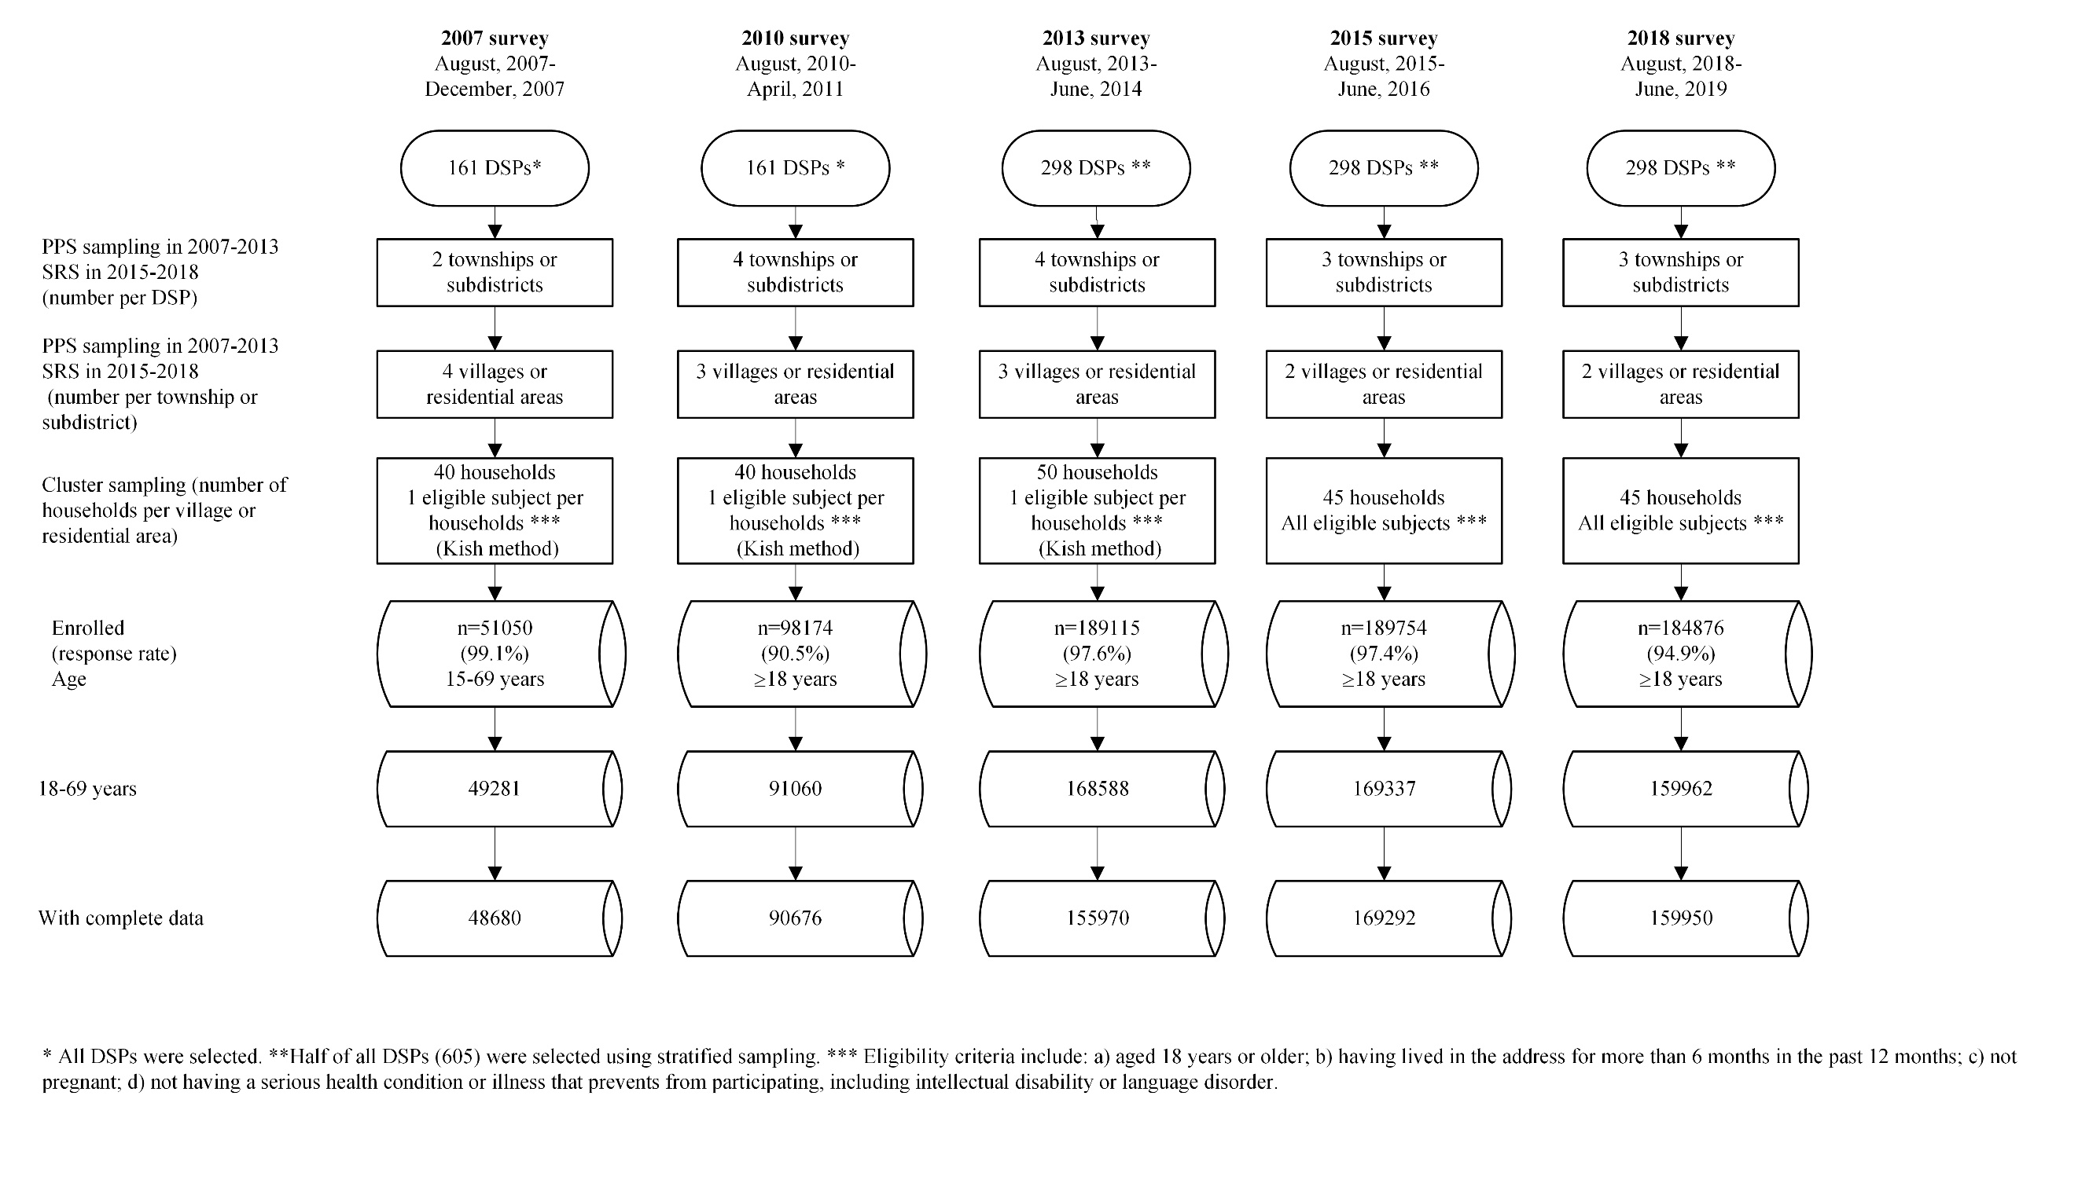

# **Fig A. Flow diagram of study design and sampling procedure of CCDRFS 2007-2018.** CCDRFS, China Chronic Disease and Risk Factor Surveillance; DSPs, Disease Surveillance Points; PPS, probability proportional to size; SRS, systematic random sampling. Biochemical data were available since 2010 survey.

# **Fig B. Prevalence of current smoking among women aged ≥ 18 years in 2018, by province and area of residence.** Date from the 2018 CCDRFS. CCDRFS: China Chronic Disease and Risk Factor Surveillance.



# **Fig C. Number of manufactured cigarettes produced annually in China from 2000 to 2020.** Data were available from the web site of National Bureau of Statistics [cited 2021 2/12/21]: https://data.stats.gov.cn/easyquery.htm?cn=C01.