S5 Appendix. Distribution of costs per unique multimorbidity (MM) combination
 | Total costs of secondary care | Potentially preventable (ACSC) costs
2017/18 costs | 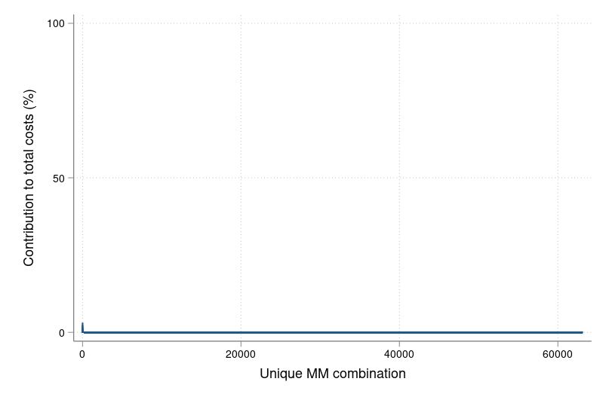 | 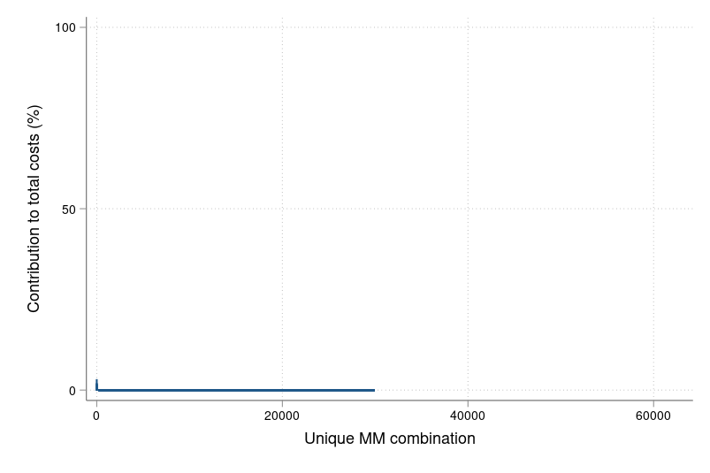
5-year costs | 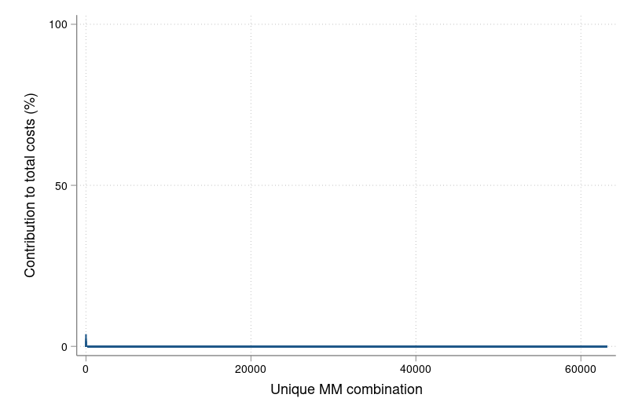 | 