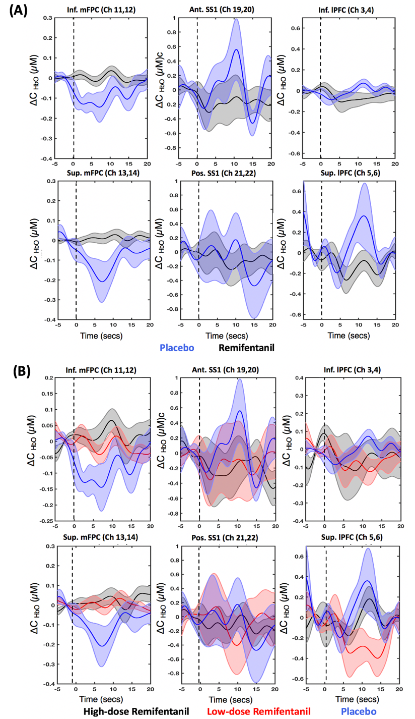
S1 Fig: Group-Averaged Hemodynamic Response in the Six Regions of Interest to the First Ablation Event: A: Remifentanil (HD + LD=black) and Placebo groups (blue); B: Remifentanil subgroups (HD=black; LD=red) and placebo (blue) group. The dotted black line indicates the start of ablation. The shaded area represents the standard error of mean. Abbreviations: Inf. mPFC, inferior medial frontopolar cortex; Sup. mPFC, superior medial frontopolar cortex; Ant. SS1, anterior superior somatosensory cortex; Pos. SS1, posterior superior somatosensory cortex; Inf. lPFC, inferior lateral prefrontal cortex; and Sup. lPFC, superior lateral prefrontal cortex.

